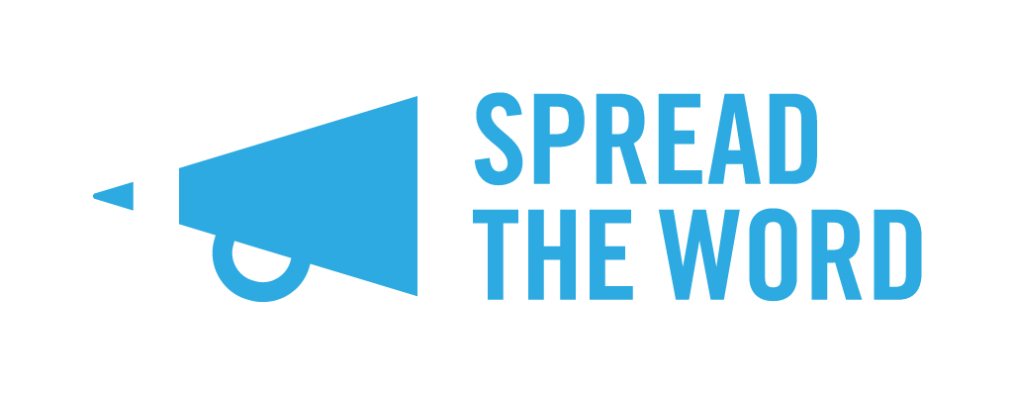
Young People’s Laureate for London Poetry Award Postal Entry Form 18 – 25 year olds category
Thanks for your interest in the Young People’s Laureate for London Poetry Award. Caleb Femi is looking forward to reading your ‘tomorrow’ themed poem.

Name:

Title of Your Poem:

Your age:

Your date of birth:

Your email address:

Your postal address:

Your postcode:

I can confirm I live in London

I can confirm that should I win or be recommended, I am willing and able to attend the Poetry Lab on 10 June 2017

Please tick here if you would like to be added to Spread the Word’s regular e-mail list.

When this form is complete, please put this with your poem and post to:
Spread the Word, The Albany, Douglas Way, London SE8 4AG.
Spread the Word will email you to confirm we have received your entry. Thanks for your entry and good luck!

