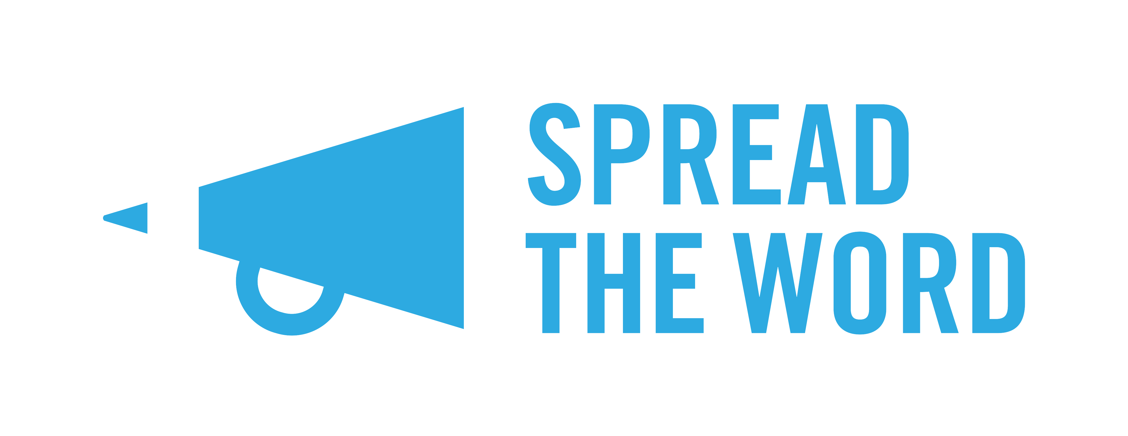
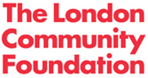
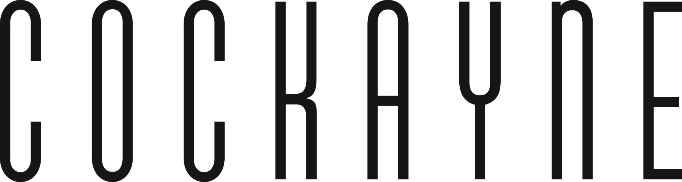

PLATFORM Application Form

Name:

Address (including postcode):
Please note that PLATFORM is only open to applicants living in London. You can check your postcode at doogal.co.uk/london_postcodes.php.

Contact number: E-mail address:

In which genre does your writing usually fit in?

poetry short story script-writing fiction

creative non-fiction cross-genre other - please specify………………

In 200 words or less, tell us why you’re applying for PLATFORM:

In 300 words or less, tell us about the idea that you have that you would like to develop with PLATFORM:

I confirm that I am over 18 and am currently un-agented and with without a publishing contract: Yes/ No

Please return this completed application form with your Writers’ CV by 5pm on Monday 2 October. We will respond to all applicants regarding the status of their application in the week commencing 30 October.

PLATFORM has been made possible thanks to the generous support of Cockayne - Grants for the Arts and The London Community Foundation.

