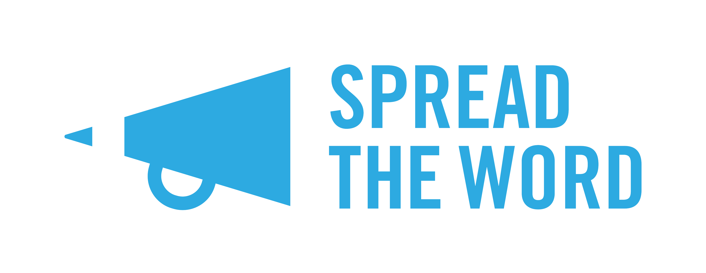
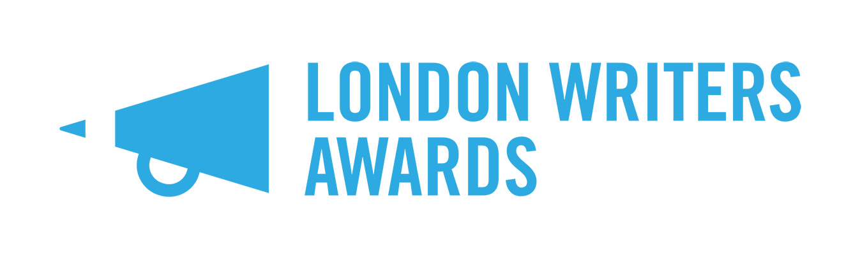

London Writers Awards: FAQs

What is The London Writers Awards?
The London Writers Awards is Spread the Word’s new annual writer development scheme, which will offer up to 30 London writers from communities currently under-represented in publishing a 9 month programme of masterclasses, critical feedback groups, WritersLabs, 1-2-1 coaching and networking opportunities.

Why are you running this programme?
Building on our Writing the Future (2015) research, the London Writers Awards have been developed to address the on-going lack of opportunities available for new and emerging writers to find an agent and receive sustained professional input and quality feedback to produce work that will be published. The London Writers Awards responds to this need by putting in place an annual development programme for London’s emerging talent, with the overt objective of increasing the number of talented writers from under-represented communities being taken up by agents and publishers.

Who is The London Writers Awards for?
The Awards are for: 18+; Black, Asian, minority ethnic (BAME), working class or working class background, and Lesbian, Gay, Bisexual, Transgender, Queer (LGBTQ) writers, and disabled writers currently living in London. Talented un-agented and unpublished writers who are writing in one of the Award’s five categories: literary fiction (including short stories); commercial fiction (e.g. romance, crime, science fiction); narrative non-fiction; YA/children’s (middle grade and YA fiction, but not picture books); and poetry.

What does The London Writers Award offer?
Successful applicants will be offered training, support and networking opportunities including:
- Participation in a critical feedback group to gain valuable feedback on your project;
- Craft and career masterclasses with leading writers and industry professionals;
- 2 WritersLabs with talks and workshops by writers, agents and publishers and a showcase event to editors and agents;
- 1-2-1 professional development coaching sessions;
- Bursaries for writers most in need;
- Access fund for disabled writers.

Do I have to pay anything?
No. Participation in the Awards is free at the point of delivery. Travel and other costs associated with participating in the Awards will not be covered. There are limited bursaries available for writers most in need. There is also an access fund to support disabled writers participating in the programme.

Will it take up much of my time?
The London Writers Awards are for writers who are committed to taking their work forward and who aspire to becoming published and having a career as a writer. You will need to be available to participate across the nine months of the programme. The critical feedback groups will take place in the evening twice a month and last 2 hours each time (fifteen sessions will take place in total); the five craft masterclasses will take place twice a month on a Saturday daytime up to December 2018 - you will need to attend your category masterclass and can choose to attend other craft masterclasses if you want to and there is space. The career masterclasses will run monthly from January 2018 to May 2019, these are attended by all Award winners as are the WriterLabs on 22 September 2018 and 23 May 2019 (the showcase event). The masterclasses and WritersLabs will last up to 5 hours each. You will also need to find time to work on your writing project so that it can progress during the programme.

What do you mean by middle grade?
Middle grade are books written for children aged roughly between 8-12 years old. They are generally 30,000 – 50,000 words in length (though fantasy can run longer). Content restrictions include: no profanity, graphic violence or sexuality. The protagonist age is typically 10 for a young middle grade novel, and up to age 13 for older, more complex books. Middle grade books tend to focus on friends, family and the character’s immediate world and relationship to it; characters react to what happens to them, with minimal self-reflection.

I write non-fiction - is this the same as narrative non-fiction and is it eligible?
The Awards are for writers of narrative non-fiction by which we mean: life writing, biography, memoir, nature writing and non-fiction with a strong literary intent. If your writing is factual, technical, scientific, journalistic, local history or travel writing it is not eligible for an Award.

How do I apply?
Applicants will need to complete an online application form and provide a sample/ extract from their work through our Submittable page. For the prose categories, applicants will need to submit a sample of writing (3,000 words maximum). For the poetry category, applicants will need to submit a maximum of 5 poems (a maximum total of 100 lines). Writing samples can be made from current work that is either a non-fiction narrative, novel, part of a short story collection, a novella or part of a poetry collection. Applications to develop individual short stories or poems will not be accepted.

What’s the application process?
Entries will be sifted by Spread the Word’s designated first readers. A writer and industry professional will then judge the sifted entries. Shortlisted applicants will be invited to interview at Spread the Word’s office at The Albany, Douglas Way, London SE8 4AG on either 21 or 22 August 2018. Offers will be made to 6 applicants in each of the 5 genre categories to make a total of 30 writers winning an Award. There will also be a limited number of bursaries awarded on further application.

Who are the judges?
This year’s judges are: Diana Evans and Lucy Luck for literary fiction; Vaseem Khan and Ella Kahn for commercial fiction; Cathy Rentzenbrink and Rukhsana Yasmin for narrative non-fiction; Daljit Nagra and Rachael Allen for poetry; and Patrice Lawrence and Aimée Felone for YA/Chidren’s.

Who is eligible to apply?
To apply for the scheme you must be over 18 years of age, living in London, currently un-agented and without an existing publishing contract. You must also meet at least one of the target areas of being from a BAME background, working class or working class background, LGBTQ, and/or a disabled writer. You will also need to be available to commit to the nine-month long programme, which will run from September 2018 to May 2019.

Do I need to have a finished novel or project to apply?
No, but you will need to have a current work in progress that you can develop during the nine-month programme. The ultimate aim for The London Writers Awards is for each writer to end the programme with a finished novel, short story collection, non-fiction book or poetry collection, which they can submit to agents and publishers. You will need to submit a sample of your writing to apply as outlined above.

I’ve done/ am doing a creative writing course – can I apply?
If you are currently or are about to be enrolled in a graduate or postgraduate creative writing programme (BA, MA or PhD) or are part of a longer-term development programme for writers you are not eligible to apply. If you have previously completed a creative writing course, please tell us in the online form why you need an Award now.

I’m a self-published writer, can I apply?
Previously self-published writers can apply with a currently unpublished work.

Who can apply for a bursary?
The London Writers Awards bursaries are aimed at writers who are: carers; care-leavers; single parents; ex-offenders and/ or on a low income by which we mean on benefits or a zero hours minimum wage contract. If you consider yourself eligible for a bursary, please complete the relevant section in the online form when submitting your application.

I have access needs what should I do?
If you are a disabled writer and have access requirements that will need to be supported for you to participate in the programme, please complete the relevant section in the online form when submitting your application.

How do I submit my application?
You can enter The London Writers Awards through our Submittable page here: https://spreadtheword.submittable.com/submit The application window will open on Monday 4 June 2018 at midday and close at 5pm on Friday 22 June. Entries submitted after the closing date will not be accepted.

What happens after I submit my application?
Spread the Word will respond to all applicants regarding the status of their application in the week commencing Monday 13 August 2018. Please note that due to the high number of applications we expect for this programme, we are unable to give individual feedback.

When does the programme start?
The London Writers Awards will start on Saturday 22 September 2018 with a WritersLab bringing together all the writers on the programme, judges and industry professionals. The programme will run through to May 2019, with the showcase WritersLab taking place on Thursday 23 May 2019.

My question isn’t listed here – what do I do?
Please also refer to our Terms and Conditions for The London Writers Awards. If still have any questions, please email Bobby at bobby@spreadtheword.org.uk.

Good luck with your application.

3 May 2018

