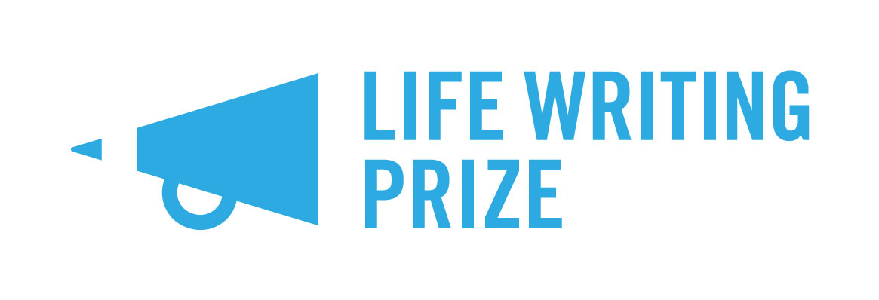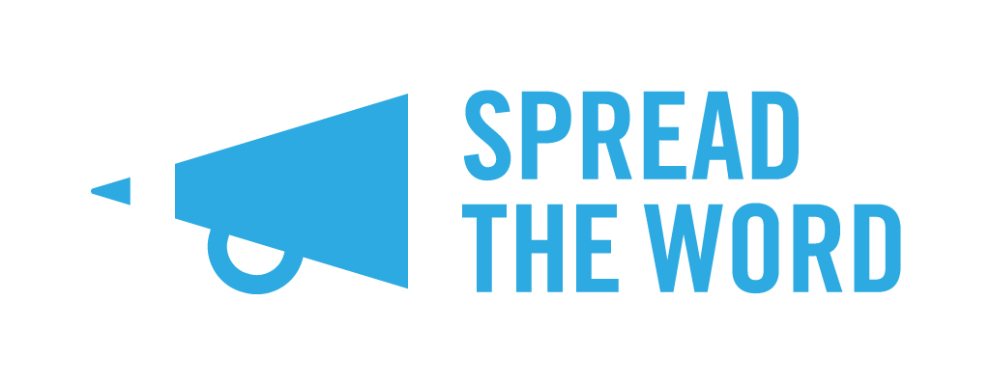

Spread the Word Life Writing Prize 2021
in association with Goldsmiths Writers Centre

FAQs

We thought it might be useful for you to take a look through these FAQs, along with the rules if you are thinking of submitting to the Prize this year. If you have a question about the Prize, please take a look through these FAQs to see if it’s answered.

- What is life writing?
For the purposes of this Prize, life writing is ‘intended to be true’, reflects someone’s own life journey or experiences and is not fiction. It is writing from the author’s own personal experience.
- Can I submit more than one piece?
No, we accept one entry per writer. Please adhere to this; if we see multiple entries we will read your first entry and discount the others. We want you to work on and submit your very best work.

- Is there a fee to submit?
Thanks to the generous donation that made the Prize happen, there is no fee for entering.

- Will you be providing feedback for all the entries?
Unfortunately, we aren’t able to provide feedback for all the entries we receive – we simply receive too many. Judges will provide a paragraph of feedback for the top twelve entries. If you are looking for feedback, we suggest that in the first place you ask a trusted critical friend, whose opinion you trust, or join a feedback group.

- Does my entry have to be entirely prose?
No, your entry doesn’t have to be entirely prose. It can contain poetry if that’s right for the piece. If you would consider your work as purely poetry, please ensure there is a strong narrative element to it, otherwise we wouldn’t consider it life writing. Graphic novel style submissions, where text accompanies image, are welcome. Playscripts, or scripts for radio / screen or texts written specifically to be performed are not eligible for this Prize.

- If I’m sending you the beginning extract of up to 5,000 words from a larger piece of writing, does my manuscript have to be finished?
No, your longer manuscript does not need to be finished. Your entry needs to be in a strong place though.

- What are the prizes?
One writer will be chosen to win the first prize of £1,500, an Arvon course of their choice (subject to availability), a writing mentor for two sessions, two years’ membership with the Royal Society of Literature, and an optional development meeting with an agent or editor. Their winning piece will be published on Spread the Word’s website and in the Life Writing Prize booklet. Two highly commended writers will receive £500 each, a writing mentor for two sessions, and an optional development meeting with an agent or editor. The writing mentors will be assigned to each writer by the Spread the Word team after a conversation with the writers. Three writers will be shortlisted, and six longlisted.

- What is a development meeting?
A development meeting is a chance to learn from the agent/editor about your work and its place in the wider world of publishing. It’s a great opportunity to ask questions to publishing industry experts and garner feedback about your work. It doesn’t mean that you will be signed up to be agented or signed up to be published. These meetings are optional for you to take up.

- What is the Life Writing Prize booklet?
We would like to offer publication in the booklet to the top twelve writers in a special Life Writing Prize booklet to showcase the top writers from the Prize to agents, editors, publishers and readers. The top three writers will definitely have their work included, and the shortlist and longlist will be offered the opportunity to have their work published in the booklet. Any shortlisted or longlisted writer published in the booklet will receive a £50 fee for their work. Depending on Covid-19 restrictions we may print the booklet to post out or distribute it as a PDF file.

- Is historical fiction eligible?
If there is a significant portion of your own experience weaved into the narrative, then yes, it does count. Writing about a period in history where you have not related it to your own experience is not eligible for this competition.

- Can I submit a piece that has been published elsewhere?
The Life Writing Prize is for entries that have not been previously published, so no.

- Can I submit something from a book that already has a publishing deal but has not yet been published?
Extracts or complete pieces that are already due to be published are not eligible for this Prize.

- Why is Spread the Word running the Prize?
Spread the Word is managing and administrating the Prize as part of its commitment to support talented writers from different backgrounds. Spread the Word has a strong track record of commitment to supporting writers making crucial steps in their career and developing initiatives for development and showcasing talent. The Life Writing Prize will provide energy and further value for emerging life writers in the UK.

- I have written a piece about my Grandfather’s life and it contains elements of my life in relation to his. Can I submit this?
If your piece weaves your experience or story in with the wider themes, then yes.

- I have previously published a novel with a medium-sized publishing house. Can I enter?
Unfortunately, the Life Writing Prize is for emerging writers who are unagented and as yet have not published a full-length work, so you are not eligible for the Prize.

- I think it’s unfair I can’t enter as I have previously published a full-length literary work.
Sorry. The Life Writing Prize can’t be everything to everyone. The Prize was established to bolster opportunities for emerging writers, and we have to qualify this with a definition. We recognise that writing life writing is different to writing fiction with the authentic and revelatory qualities requiring a different sense of bravery, but Spread the Word and the Prize donor want to place the Prize’s emphasis on emerging voices.

- I have previously had a full-length play professionally produced at a theatre. Can I enter?
Unfortunately, the Life Writing Prize is for emerging writers who are unagented and as yet have not published or had a full-length work performed, so you are not eligible for the Prize.

- I have self-published novels previously. Can I enter?
It is ok to submit to the Prize if you have only self-published novels, as long as you have not had a publishing contract or been published by a publishing house.

- I want to enter a piece of writing that I’ve published on my blog. Can I enter it?
Unfortunately not. If you want to rewrite it significantly and submit it to us, that’s ok. We want the Prize to be for new pieces of writing that are yet to find readers.

- I have a significant number of journalism credits, but I have never had a full-length work published, performed or broadcast according to your definition. Can I still enter?
Yes, you can. We recognise that writing journalism is a wholly different style to writing creatively. As long as you haven’t had a full-length work published / performed or broadcast previously, you are welcome to enter.

- Can I enter something that I entered to the Life Writing Prize last year?
If you previously won or were highly commended in the Prize, you cannot enter anything. If you didn’t win or were highly commended but were shortlisted or longlisted, you can’t enter the same piece. If you have previously entered and weren’t placed in the top 12, you are welcome to enter something you have previously entered but we would encourage you to refine and edit your work to make it really sing.

- I have previously lived in the UK but am now based abroad. Can I enter?
Unfortunately not. The competition is open to writers based in the UK. We want to ensure that those who do well in the competition are supported and are able to take up the offers available to the winners, so you do need to be based in the UK to enter.

- I was not born in the UK, but I now live here. Can I still enter?
Yes, anyone over 18 residing in the UK is welcome to enter, you do not have to have been born in the UK.

- Who are the judges for the prize?
The 2021 Life Writing Prize will be judged by Catherine Cho, Damian Barr and Frances Wilson.

- Why has the Prize been established?
The Prize has been established to:
- Provide a career changing opportunity to a creative life writer
- Showcase energy and quality in the life writing sector
- Provide an attractive opportunity for talented aspiring life writers to submit their work and achieve recognition for their work

- How long has the Prize been running for?
The first Prize winner was announced in 2017. The Prize will run for at least five years in the first instance.

- Who is the Prize Patron?
Blake Morrison is the Life Writing Prize Patron.

- How is the Prize funded?
The Prize is funded by a personal donation from Joanna Munro. Other kinds of support for the Prize comes from its partners, Goldsmiths Writers Centre, Arvon, and the Royal Society of Literature.

- I’m a publisher or agent. How can I get involved?
We’d love to hear from you. Email hello@spreadtheword.org.uk if you’d like to be involved in the Life Writing Prize and we’ll see what we can do.

- I’d like to enter the Prize but I still have a question.
Email hello@spreadtheword.org.uk and we’ll do our best to answer your query.

