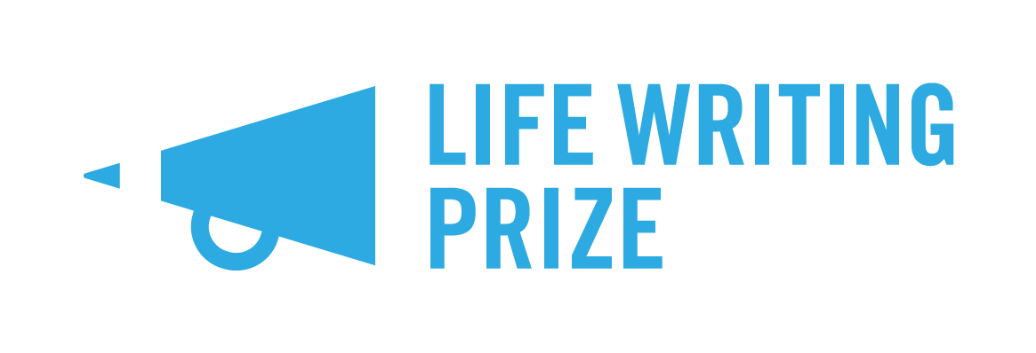
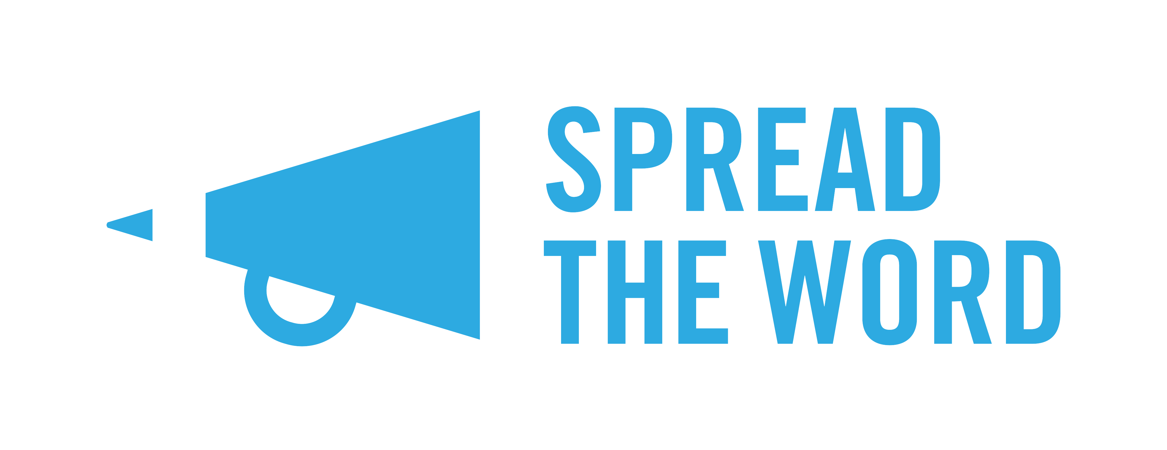

Our Life Writing Prize 2021

We are Spread the Word.

We give support and advice to writers to get their work published.

We want to tell you about our Life Writing Prize. Life Writing is a piece of writing or a story based on truth. We started the Life Writing Prize in 2017 because we wanted to:

- Give a career changing chance to a creative life writer

- Showcase talented writers in Life Writing

- Give new and emerging life writers the chance to send in their work and get noticed.

We are running the Life Writing Prize together with Goldsmiths Writing Centre and we would like you to enter. It’s free to enter and we are looking for writers from across the UK.

This guide tells you everything you need to know about the Prize including:

- What is Life Writing
- When you can enter and how
- Rules about who can enter
- Our judges
- What the prize gives you
- Meeting with an agent or editor
- Getting published in the Life Writing Prize Booklet
- Any other questions

What is Life Writing

Life writing means writing about your life. It’s when you write something from your own personal experience. Life writing doesn’t have to be in a prose style. You can include poetry if you want to, but it must have a narrative story line that fits with the story.

You can send us a graphic novel with words and images as long as it fits with life writing. You can also send stories that are from history.

Please don’t send us a play or a script for TV or radio. We can only accept stories that are written about your life.

When you can enter and how

The Prize will open for entries at midday on Monday 2 November 2020 and close for entries at 11.59pm on Monday 1 February 2021. You can enter online by visiting: https://spreadtheword.submittable.com/submit or you can enter by post. To enter by post you will need to download a postal entry form from our website here: https://www.spreadtheword.org.uk/projects/life-writing-prize/

Rules about who can enter

Anyone can enter the Life Writing Prize, from anywhere in the UK but there are some rules. We are looking for writers from different background that haven’t had their work published before.

If you want to enter then you must not have published
- A full-length piece of work before. Full-length means a document or manuscript that is longer than 50,000 words.

- Ten or more short stories

- A theatre script, screenplay or radio play

- A book of poems in a collection

- A blog that has already been published online.

You should not have an agent and your writing must be in English.

Because the Prize is for new writers, we can’t accept work if you either won or were one of our top twelve writers last year.

If you didn’t get listed by our judges last year, then you can send us the same piece of work but please look at it again and make it as good as you can.

You can send us work that is self-published.

Our judges

The judges for the Life Writing Prize are

- Catherine Cho

- Damian Barr

- Frances Wilson

Our Life Writing Prize patron is Blake Morrison.

The Prize is paid for by Joanna Munro. We also get support from our partners Goldsmiths Writers Centre, Arvon and the Royal Society of Literature.

What the Prize gives you

If you win first prize, you will get:
- £1,500 prize money

- A place on an Arvon writing course

- A writing mentor for two sessions

- Two years membership with the Royal Society of Literature

- A meeting with an agent or editor – if you want it.

We will publish your story on the Spread The Word website and in the Life Writing Prize booklet.

We will also choose two more prize winners. They will each get

- £500 prize money

- A writing mentor for two sessions

- A meeting with an agent editor – if you want it.

We will talk to you about what kind of mentor you might to work with. We will choose six writers to go on our long list, then narrow this down to three before we make our final choice.

We are sorry but unless you are chosen as one of our top 12 writers, we won’t be able to give you feedback on your writing. If you do want feedback, why not ask a friend or a writer’s feedback group?

Meeting with an agent or editor

Having a development meeting with an agent editor can really help you to get published. This is a space for you to ask questions and get advice from publishing experts. You can also get feedback on your writing. You don’t have to take this opportunity if you don’t want to, but it could be really helpful.

Getting published in the Life Writing Prize booklet

We will publish all the stories from the twelve top writers we choose. We will share this booklet with agents, editors, publishers and readers. The top three writers will definitely get their stories published in the booklet.

We will offer all the writers on our long list and short list, the chance to be published in the booklet too. You will get a £50 fee if we use your story in the booklet. We will either print the booklet and post it and/or have it available to download as a PDF. This will depend on what happens with COVID-19.

Any other questions

If you have any other questions that we haven’t covered in this information, please send an email to hello@spreadtheword.org

If you’re an agent or publisher, we’d love to hear from you too!

