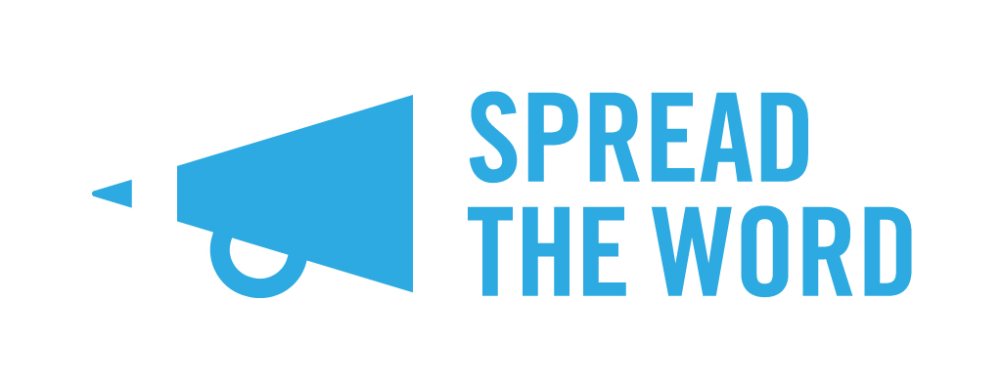

Life Writing Prize 2021 Postal Entry Form
If you are entering the Life Writing Prize 2021 by post, please complete this short entry form and attach it to your 5,000 word (max) entry and post to:
Life Writing Prize, Spread the Word, The Albany, Douglas Way, London SE8 4AG. If you would prefer to enter online, you can do that at:

https://spreadtheword.submittable.com/submit

Deadline for entries is 11.59pm, Monday 1 February 2021. Entries cannot be accepted after this date.

- What is your name?

- What is the title of your Life Writing Prize entry?

- Please state whether your extract is: (please delete as appropriate)

a) complete piece of up to 5000 words or
b) the beginning extract of no more than 5000 words in length of a longer work

- What is your email address?

- What is your phone number?

- What is your postal address and postcode?

- Please confirm that you are eligible for the Prize by ticking all the relevant boxes. Note that if any of these do not apply to you, you are not eligible to enter the Prize.
I can confirm all the following apply to me:
I live in the UK
I have read and agree to the Life Writing Prize 2021 rules (please visit the Spread the Word website for details)
I am over 18
I do not have a literary agent
I have not had a previously full-length work published, performed or broadcast

8. Please help us monitor and develop the Prize by letting us know if the following applies to you:
I have never had anything published before

Spread the Word will be in touch with all entrants in April 2021. Please note we are not able to return entries, but we will acknowledge receipt.

