Poetry and Place
Dear Poet,
Thank you so much for your interest in this project. It was originally developed as a 5-pack postal poetry course for Lewisham-based writers, with support and feedback. After the success of the project, we are making it available for free online, for anyone who wishes to undertake the exercises (although there will be no feedback available).
My name is Jamie Hale, and I’m an internationally award-winning nature poet. I was one of the winners of the London Writers’ Awards in 2018, and have been published in multiple magazines. I am currently finishing my first poetry pamphlet and collection, and I run lots of different poetry workshops.
This course is free, with the development funded by Lewisham Council, and supported by Spread the Word. It is designed to help people start (or continue, or return to) reading and writing poetry, and to feel like part of a community even if you can’t get out much. The five themes will be:
- Past Lewisham – using old photos, we’ll explore how Lewisham used to look and write nature (‘pastoral’) poetry
- Homes – real and imaginary homes you’ve had, and writing a ballad (a story poem with rhyme and rhythm)
- Lewisham now – writing haiku (short, three line poems) exploring what Lewisham is like – the bad and the good
- Future Lewisham – writing poems whose lines spell out words vertically, exploring dreams for a future Lewisham
- The meaning of home – writing sonnets (rhyming love poems) about what home means to us individually
This course will contain five packs of poetry exercises for you to either print and fill out or fill out in the document.
They’re Lewisham-based, but there’s no obligation to write about Lewisham – if you want to pick a different place – please do. This is about freedom and writing.
Remember, there’s no right or wrong with poetry – and have fun!

PACK ONE - Lewisham in the past, and writing pastoral poetry
Here are some photos of what this area used to look like – all countryside and small village. It’s changed a lot…
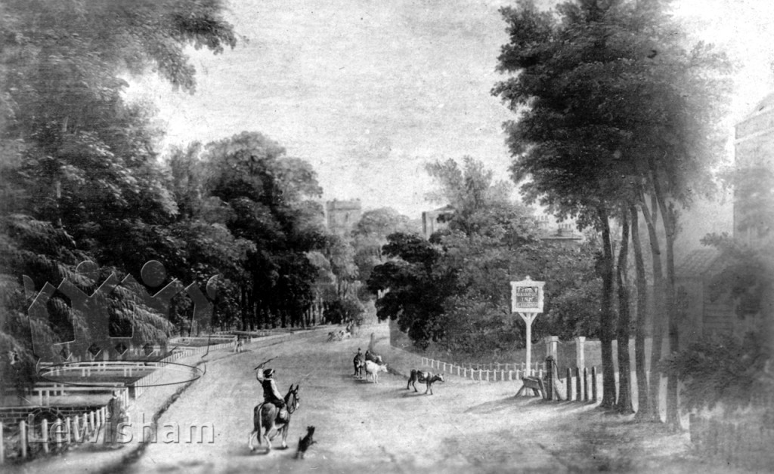
Lewisham High Street, 1830s
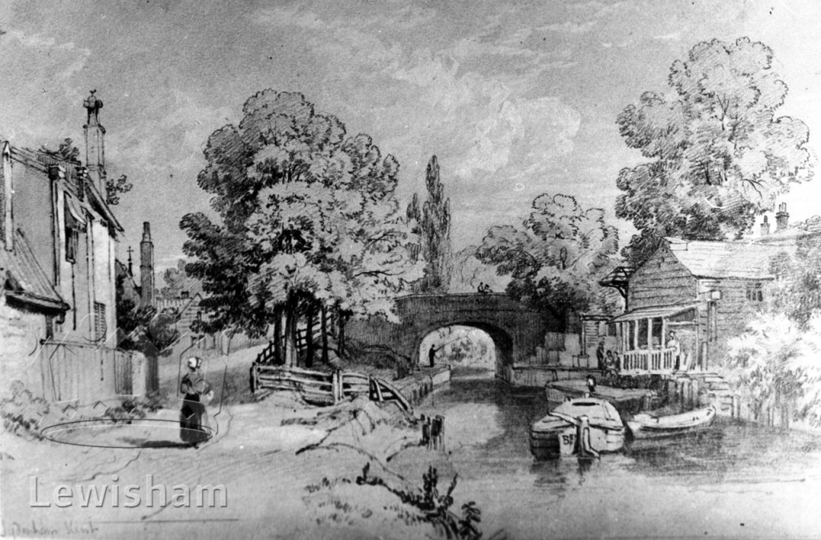
Sydenham Bridge from the north, 1830s

A pastoral poem is one that talks about nature in an idealised fashion, as if it were far better than cities. Pastoral poems often contain images of countryside life, shepherds, and images of people relaxing in nature rather than working. A pastoral poem doesn’t have to rhyme, but it can. Most pastoral poems were written before the 1700s, but there are some modern ones. Here’s an example of part of a famous traditional pastoral poem:

The Passionate Shepherd to His Love
Christopher Marlowe
Come live with me and be my love,
And we will all the pleasures prove,
That Valleys, groves, hills, and fields,
Woods, or steepy mountain yields.

And we will sit upon the Rocks,
Seeing the Shepherds feed their flocks,
By shallow Rivers to whose falls
Melodious birds sing Madrigals.

And I will make thee beds of Roses
And a thousand fragrant posies,
A cap of flowers, and a kirtle
Embroidered all with leaves of Myrtle;

A gown made of the finest wool
Which from our pretty Lambs we pull;
Fair lined slippers for the cold,
With buckles of the purest gold;

A belt of straw and Ivy buds,
With Coral clasps and Amber studs:
And if these pleasures may thee move,
Come live with me, and be my love.

The Shepherds’ Swains shall dance and sing
For thy delight each May-morning:
If these delights thy mind may move,
Then live with me, and be my love.

Having read that poem, what do you think the nymph might think about the shepherd’s invitation
Take this first line, and continue writing a reply to the Shepherd, pretending to be the nymph.
Remember, it doesn’t have to rhyme. Do this before you turn the page over

If all the world and love were young…

__________________________________________________________________________

__________________________________________________________________________

__________________________________________________________________________

__________________________________________________________________________

This is a reply to the first poem by a different poet, pretending to be the nymph and rejecting the shepherd

The Nymph’s Reply to the Shepherd
Walter Raleigh

If all the world and love were young,
And truth in every Shepherd’s tongue,
These pretty pleasures might me move,
To live with thee, and be thy love.

Time drives the flocks from field to fold,
When Rivers rage and Rocks grow cold,
And Philomel becometh dumb,
The rest complains of cares to come.

The flowers do fade, and wanton fields,
To wayward winter reckoning yields,
A honey tongue, a heart of gall,
Is fancy’s spring, but sorrow’s fall.

Thy gowns, thy shoes, thy beds of Roses,
Thy cap, thy kirtle, and thy posies
Soon break, soon wither, soon forgotten:
In folly ripe, in reason rotten.

Thy belt of straw and Ivy buds,
The Coral clasps and amber studs,
All these in me no means can move
To come to thee and be thy love.

But could youth last, and love still breed,
Had joys no date, nor age no need,
Then these delights my mind might move
To live with thee, and be thy love.

Which poem did you prefer? Why?
Think about the rhythm of the lines, read them out to yourself, think about the words they chose, how they made the poem rhyme…
__________________________________________________________________________

__________________________________________________________________________

__________________________________________________________________________

__________________________________________________________________________
Look back at the photos from earlier, and pick which photo that you want to write about.
Draw a mind-map of words that you associate with the picture you’ve chosen. Here are some to start with:
Verdant | Stand
Fresh | Path
Growth | Stone
Shade | River
Calm | Currant
Flow | Leaves
Arch | Trees
Stand | Stroll
Brick | Clouded
Grass | Chimney
Tree | Park
Fence | Sign
Boat | Walk
Swift | Ride
Equine | Avenue
Tall | Leap

If you want it to rhyme, here are some words that might help:

Grow | Mean | Grass | One | Sky | Arc | Field
Slow | Been | Pass | Run | Fly | Lark | Yield
Blow | Green | Last | Sun | Lie | Park | Tree
Flow | Seen | Glass | Done | Tie | Mark | The
Though | Dream |  |  | Why | Bark | Be
Oh |  |  |  | By | Dark | See
Row |  |  |  | Sigh | Hark | Me
Sew

Now, how would you describe the picture for someone who couldn’t see it.
Think about the words you would use as you explained what the picture shows. Try not to say “there is a building by the road” and instead “the road is lined with grass, and beside it a building stands tall and proud, the bricks glowing in the sun”. Feel free to invent things – you don’t have to be accurate

_______________________________________________________________________________________________

_______________________________________________________________________________________________

_______________________________________________________________________________________________

_______________________________________________________________________________________________

_______________________________________________________________________________________________

_______________________________________________________________________________________________

Writing the poem - draft
Now it’s time to put all the pieces together, and write a poem. We’re going to write a poem with four verses. Each verse will have four lines, and they’ll describe the picture. The lines can rhyme, but they don’t have to.

_______________________________________________________________________

_______________________________________________________________________

_______________________________________________________________________

_______________________________________________________________________

_______________________________________________________________________

_______________________________________________________________________

_______________________________________________________________________

_______________________________________________________________________

_______________________________________________________________________

_______________________________________________________________________

_______________________________________________________________________

_______________________________________________________________________

_______________________________________________________________________

_______________________________________________________________________

_______________________________________________________________________

_______________________________________________________________________

Pastoral poem - final

Title: __________________________________________________________________

Author: ________________________________________________________________

_______________________________________________________________________

_______________________________________________________________________

_______________________________________________________________________

_______________________________________________________________________

_______________________________________________________________________

_______________________________________________________________________

_______________________________________________________________________

_______________________________________________________________________

_______________________________________________________________________

_______________________________________________________________________

_______________________________________________________________________

_______________________________________________________________________

_______________________________________________________________________

_______________________________________________________________________

_______________________________________________________________________

_______________________________________________________________________

PACK TWO – THE BALLAD
For this pack, we’re going to think about places you’ve called home. Maybe you’ve lived in six countries, or maybe you’ve never left the house you were born in, but where do you go in your head when someone talks about home? Sometimes I just think of my bedroom, and sometimes the city I’ve most enjoyed living in. Home is a concept, sometimes, rather than an actual place. Other times I’m not thinking of the house at all, but of something near there – or something that made me feel like home.
We’re also thinking about the ballad. A ballad is a type of poem that tells a story. It tends to rhyme in a very specific way, and it’s a poem you could imagine setting to music. Last week, with the pastoral poem you were able to explore rhyme, but it was up to you whether you wanted your work to rhyme, whereas this week we’re going to try to produce something that rhymes, as is traditional for ballads.

The Rime of the Ancient Marinere by Samuel Taylor Coleridge
This is an excerpt from the beginning of the poem, which is some 400 lines long

A | It is an ancient Mariner, | A ‘mariner’ is a type of seaman
B | And he stoppeth one of three.
C | 'By thy long grey beard and glittering eye,
B | Now wherefore stopp'st thou me? | ‘Why are you stopping me’
A | The Bridegroom's doors are opened wide,
B | And I am next of kin;
C | The guests are met, the feast is set:
B | May'st hear the merry din.' | “May’st” means “you may”
A | He holds him with his skinny hand,
B | 'There was a ship,' quoth he. | “Quoth he” means “he said”
C | 'Hold off! unhand me, grey-beard loon!' | “Let go of me, you grey-bearded old man”
B | Eftsoons his hand dropt he. | “Eftsoons” means “one again” – ‘once again he dropped his hand’
A | He holds him with his glittering eye—
B | The Wedding-Guest stood still,
C | And listens like a three years' child:
B | The Mariner hath his will. | “The seaman had his way”
A | The Wedding-Guest sat on a stone:
B | He cannot choose but hear;
C | And thus spake on that ancient man, | “Spake” means “spoke” – “the old man kept speaking”
B | The bright-eyed Mariner.
A | 'The ship was cheered, the harbour cleared, | “People cheered the ship as it left the harbour”
B | Merrily did we drop | “We dropped out of sight”
C | Below the kirk, below the hill, | “Kirk” means “church”
B | Below the lighthouse top.
A | The Sun came up upon the left,
B | Out of the sea came he!
C | And he shone bright, and on the right
B | Went down into the sea.

Ballad poems usually tell a story. What do you think is happening in this story?

__________________________________________________________________________

__________________________________________________________________________

__________________________________________________________________________

__________________________________________________________________________

If-ing by Langston Hughes Candle in the Wind by Elton John and Bernie Taupin

A | If I had some small change
B | I’d buy me a mule,
C | Get on that mule and
B | Ride like a fool.
A | If I had some greenbacks
B | I’d buy me a Packard,
C | Fill it up with gas and
B | Drive that baby backward.
A | If I had a million
B | I’d get me a plane
C | And everybody in America’d
B | Think I was insane.
A | But I ain’t got a million,
B | Fact is, ain’t got a dime—
C | So just by if-ing
B | I have a good time!
A | Goodbye Norma Jean
B | Though I never knew you at all
C | You had the grace to hold yourself
B | While those around you crawled
A | They crawled out of the woodwork
B | And they whispered into your brain
C | They set you on the treadmill
B | And they made you change your name
A | And it seems to me you lived your life
B | Like a candle in the wind
C | Never knowing who to cling to
B | When the rain set in
A | And I would have liked to have known you
B | But I was just a kid
C | Your candle burned out long before
B | Your legend ever did

Having read those three poems, have a look at which of them, and how they rhymed. For each four-line verse of each poem, mark the lines that rhymed.

In each of those three ballads, even though they’re all very different, it’s always the second and fourth line of the verse (also known as a stanza), that rhymed. If you read them out to yourself, you’ll notice that each of them also has a rhythm. The ballad is a form of poem that arose from songs, and so is generally written as if it were to be sung.

Try and write out the rhythm of one of the lines of The Rime of the Ancient Marinere as “dee” or “dum”

__________________________________________________________________________

__________________________________________________________________________

Now try and do the same with one of the lines of Candle in the Wind

__________________________________________________________________________

__________________________________________________________________________

What did you notice?

__________________________________________________________________________

__________________________________________________________________________

__________________________________________________________________________

__________________________________________________________________________
Because ballads were traditionally set to music, they often have a very similar rhythm. If you think of Elton John, Candle in the Wind you may remember the tune. Here’s some sheet music with the notes and rhythm to the chorus (which is known in poetry as the ‘refrain’). 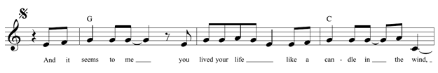

Think of the word “home” and what it means to you as an idea.
I might say “comfort”, “safety”, “love”, “warmth”, but you might have other ideas

The idea of ‘home’

Now think of words you might use to describe somewhere that’s felt like a “home” to you – or somewhere imaginary that feels like it could be a “home”
I might say “green”, “hilly”, “fresh”, “craggy”, “gorse bushes”

What “home” looks like

Now it’s time to think of your story. Do you have a favourite story that connects to the idea of “home” for you? Here are some ideas. It shouldn’t be very long, it only really needs to be a single, line or image for you to use
- A favourite story from when your children were young, something they did
- A line from your favourite fairy-tale
- A photograph from your childhood that tells a story of what being at home means for you
As an example, I’ve got a favourite photo, showing me dressed all in blue, feeding a deer from my hands in a field behind my house
Write out your story, just as a story:

______________________________________________________________________________________________

______________________________________________________________________________________________

______________________________________________________________________________________________

______________________________________________________________________________________________

______________________________________________________________________________________________

______________________________________________________________________________________________

Now think about how you’d structure it as a poem that tells a story in four verses:
- The beginning of the story – what happens?
Here I might describe what the fields behind my house looked like at mid-afternoon
- The beginning of the story – what happens?
Here I might describe the child standing in the fields and seeing a deer in the distance
- The turn – does something completely unexpected happen?
Here I might describe my surprise at the deer coming closer to me
- How does the story end? What’s the final image?
Here I might describe what it was like to have the photo of the deer and I taken, and how looking back at it now feels

Next, think about words that rhyme that might work in your ballad. Remember that the second and fourth lines need to rhyme. For mine, I might think
- “Grows” for the cornfields behind my house “glow” for the late afternoon sun
- “Hill” from where I saw the deer emerging “still” for how the world and I felt
- “Stand”, describing what I’m doing as the child “hand” because I’m offering the deer food
- “Flash”, for the camera as the photo was taken “dash”, as the deer fled the flash suddenly

- ____________________________ _______________________________
- ____________________________ _______________________________
- ____________________________ _______________________________
- ____________________________ _______________________________
If you are writing a ballad with four verses, how might your story break down into it? Try drawing out what you’re planning to write in each verse:
Ballad - draft
We’ve now got all of the parts of the ballad. We know roughly what the rhythm of a ballad is, we’ve got an idea of what ‘home’ means to us, and we’ve got a story about home to put into the form of a ballad. Now all we have to do, is put everything together into a ballad. Remember that lines 2 and 4 should rhyme each time.

1. _______________________________________________________________________

2. _______________________________________________________________________

3. _______________________________________________________________________

4. _______________________________________________________________________

1. _______________________________________________________________________

2. _______________________________________________________________________

3. _______________________________________________________________________

4. _______________________________________________________________________

1. _______________________________________________________________________

2. _______________________________________________________________________

3. _______________________________________________________________________

4. _______________________________________________________________________

1. _______________________________________________________________________

2. _______________________________________________________________________

3. _______________________________________________________________________

4. _______________________________________________________________________

Ballad - final

Title: ___________________________________________________________________

Author: _________________________________________________________________

1. _______________________________________________________________________

2. _______________________________________________________________________

3. _______________________________________________________________________

4. _______________________________________________________________________

1. _______________________________________________________________________

2. _______________________________________________________________________

3. _______________________________________________________________________

4. _______________________________________________________________________

1. _______________________________________________________________________

2. _______________________________________________________________________

3. _______________________________________________________________________

4. _______________________________________________________________________

1. _______________________________________________________________________

2. _______________________________________________________________________

3. _______________________________________________________________________

4. _______________________________________________________________________

PACK THREE - HAIKU
Haiku are very easy to write – but very difficult to write really well. It’s a form that really makes you think about what words you’re choosing and why you’re choosing them.
The Japanese haiku is a very constrained form, and very different from the English haiku.
- A Japanese haiku takes place in a single line, with three phrases. A haiku has 17 ‘on’ or sounds (which is about as long as 12 English syllables). These on are arranged as five – seven – five.
- It contains a reference to seasons. These aren’t always obvious, but these references generally come from a list of possible ones. ‘Season words’ include words like ‘spring’, but ‘frog’ is also associated with spring, while ‘young leaves’ is associated with summer. The haiku will choose one word to reflect the season.
- It contains a ‘cutting word’ at the end of one of the lines. This word serves the function of breaking the sonnet into two parts.

Here are some famous Japanese haiku:
古池や蛙飛びこむ水の音  Old pond  Frog jumps in  Sound of water¹  -- Matsuo Bashō | 寒月に木を割る寺の男かな  The old man of the temple,  Splitting wood  In the winter moonlight.  --Buson (Trans. R. H. Blyth)
枯枝に烏のとまりけり秋の暮  On a withered branch  A crow has stopped  Autumn evening  -- Matsuo Bashō | 蜻蛉や狂ひしつまる三日の月  The dragonflies  Cease their mad flight  As the crescent moon rises.  --Kikaku (Trans. R. H. Blyth)
The English haiku is a very different form.
It is arranged in three lines, the first and last with 5 syllables (sounds) and the middle with 7 syllables.

(5) The first line has five
(7) Middle seven syllables
(5) Finish with five more

Reference to a season isn’t necessary, although we’ll work on it in our haiku. There is also no clear English equivalent to the ‘cutting word’, but writers often use a ‘–‘ or line break, although this isn’t seen as necessary either.
Lots of haiku have been written that break these rules, for example this famous one by Ezra Pound titled In A Station On The Metro.
The apparition of these faces in the crowd:
Petals, on a wet, black bough
We are going to focus on writing haiku that stick to the rules, because by doing that and learning what works, it’s easier to then decide to break them.
Here are some famous English haiku recommended by the British Haiku Society:
even here a child  looking for four-leaf clovers  on Culloden Moor  --David Cobb | caught in a storm  wearing nothing waterproof  except mascara  --Janice Fixter
shipping oars
I hold my breath to hear
snow on the water

--David Steele

None of those contain punctuation to function as a ‘cutting word’, but in all three there’s a change in tone between the first line and the second two lines, which functions similarly. The one by David Cobb implies a season – spring or summer – through the image of looking for clover, while the ones by Janice Fixter and David Steele have a clear seasonal reference, through “snow” or “storm”.

We are going to write some Lewisham-themed haiku. There will be four haiku, one for each season. For each haiku you will need some sort of strong image of Lewisham, and to think of how your feelings about the image come through. We are going to use a kigo (a season word), and if you wish, you can also use a kireji – some kind of ellipsis (…), dash – , or line break to cut across the haiku if you wish.

Here’s a table giving you some ideas in English for words you might be able to use as kigo – season words – have a think and add words that you associate with seasons below:
Spring | Summer | Autumn | Winter
Leap | Shade | Chilly | Freeze
Rabbit | Blazing | Fog | Cold
Grass | Swimming | Apple | New Year
Birth | Drought | Golden leaves | Snowflakes
Shower | Hot | Harvest | Fireplace
Frog | Firefly | Sunset | Duck
Dandelion | Rainbow | Leaf-fall | Sleet
Now have a think of some strong images or memories you might have of Lewisham, especially if you can tie them to a season. The image doesn’t have to be about the season, but you should think about how the season would fit into the image or memory you’re using. Don’t try and write a haiku yet, you’re just thinking about the memories you might want to use.
In a haiku, it’s important that you show, don’t tell. If you want to make us feel something, show us it, don’t tell us to feel it.
- Spring
___________________________________________________________________________
___________________________________________________________________________
___________________________________________________________________________

___________________________________________________________________________
- Summer
___________________________________________________________________________
___________________________________________________________________________
___________________________________________________________________________
___________________________________________________________________________

- Autumn
___________________________________________________________________________
___________________________________________________________________________
___________________________________________________________________________
___________________________________________________________________________

- Winter
___________________________________________________________________________
___________________________________________________________________________
___________________________________________________________________________
___________________________________________________________________________

Now, take the same images, and try to create them using as few words as possible. You’re not describing the image this time, you’re just trying to make the reader feel the image you’re using
- Spring

___________________________________________________________________________
___________________________________________________________________________
- Summer

___________________________________________________________________________
___________________________________________________________________________
- Autumn
___________________________________________________________________________
___________________________________________________________________________
- Winter
___________________________________________________________________________
___________________________________________________________________________

Now, let’s work on turning those into haiku. Think about which words are the most important. Cut out unnecessary adjectives (describing words like “prettily” or “hungrily”) – you’re going to try and write something that doesn’t need that to emphasise the scene in it. If this is essential to the poem then keep it, but if not, can you lose it? Cut out qualifiers like “might”, or “some”. Again, if these are essential to the poem you should keep them, but otherwise remove them from the poem – they’re using up syllables you might need for something else

Think about the central image in your poem, then write. Try lots of drafts. And remember, the rules are there to be broken if you wish:

Spring:

______________________________________ ______________________________________
______________________________________ ______________________________________
______________________________________ ______________________________________
______________________________________ ______________________________________
______________________________________ ______________________________________
______________________________________ ______________________________________

Summer:

______________________________________ ______________________________________
______________________________________ ______________________________________
______________________________________ ______________________________________
______________________________________ ______________________________________
______________________________________ ______________________________________
______________________________________ ______________________________________
Autumn:

______________________________________ ______________________________________
______________________________________ ______________________________________
______________________________________ ______________________________________
______________________________________ ______________________________________
______________________________________ ______________________________________
______________________________________ ______________________________________
Winter:

______________________________________ ______________________________________
______________________________________ ______________________________________
______________________________________ ______________________________________
______________________________________ ______________________________________
______________________________________ ______________________________________
______________________________________ ______________________________________

Haiku – final – write out your favourite one or two for each season

Author: ________________________________________________________________
Spring:
______________________________________ ______________________________________
______________________________________ ______________________________________
______________________________________ ______________________________________
Summer:
______________________________________ ______________________________________
______________________________________ ______________________________________
______________________________________ ______________________________________
Autumn:
______________________________________ ______________________________________
______________________________________ ______________________________________
______________________________________ ______________________________________
Winter:
______________________________________ ______________________________________
______________________________________ ______________________________________
______________________________________ ______________________________________

PACK FOUR – ACROSTICS AND ABECEDARIAN
In this section, we’re going to use another strict form, starting with what’s called an acrostic poem, and then moving onto a full abecedarian. An acrostic poem takes a word as its starting point, and writes that vertically. It then uses those letters as the first letters for all of the lines of the poem. An abecedarian is a poem whose lines begin with consecutive letters in the alphabet, and is a very old form, historically found in Hebrew texts. Both of these forms allow you to be as serious and thought out or as playful as you want.
It can be hard trying to stick to rules when writing poems – and can feel like it stifles your creativity. If you feel that way, there’s no obligation to stick to the rules, but I’ve learned from trying lots of really challenging exercises that you can often discover an unexpected level of creativity from pushing away at an exercise that’s hard. So if you’re struggling with exercises it’s up to you.
Have you thought about sharing your poetry with friends and family? It can be quite frightening asking people for their opinions but people will often be very supportive and loving. You could also share these exercises with them – maybe copy and post them to a friend, so you can share your work back and forth. Creativity is a great way of building and maintaining relationships, and lets you connect with people on a different level. I hope that you find it as fulfilling as I do.

A Poem for S.
by Jessica Greenbaum
Because you used to leaf through the dictionary,
Casually, as someone might in a barber shop, and
Devotedly, as someone might in a sanctuary,
Each letter would still have your attention if not
For the responsibilities life has tightly fit, like
Gears around the cog of you, like so many petals
Hinged on a daisy. That’s why I’ll just use your
Initial. Do you know that in one treasured story, a
Jewish ancestor, horseback in the woods at Yom
Kippur, and stranded without a prayer book,
Looked into the darkness and realized he had
Merely to name the alphabet to ask forgiveness—
No congregation of figures needed, he could speak
One letter at a time because all of creation
Proceeded from those. He fed his horse, and then
Quietly, because it was from his heart, he
Recited them slowly, from aleph to tav. Within those
Sounds, all others were born, all manner of
Trials, actions, emotions, everything needed to
Understand who he was, had been, how flaws
Venerate the human being, how aspirations return
Without spite. Now for you, may your wife’s
X-ray return with good news, may we raise our
Zarfs to both your names in the Great Book of Life.

Abecedarian Requiring Further Examination of Anglikan Seraphym Subjugation of a Wild Indian Rezervation
by Natalie Diaz

Angels don’t come to the reservation.
Bats, maybe, or owls, boxy mottled things.
Coyotes, too. They all mean the same thing—
death. And death
eats angels, I guess, because I haven’t seen an angel
fly through this valley ever.
Gabriel? Never heard of him. Know a guy named Gabe though—
he came through here one powwow and stayed, typical
Indian. Sure he had wings,
jailbird that he was. He flies around in stolen cars. Wherever he stops,
kids grow like gourds from women’s bellies.
Like I said, no Indian I’ve ever heard of has ever been or seen an angel.
Maybe in a Christmas pageant or something—
Nazarene church holds one every December,
organized by Pastor John’s wife. It’s no wonder
Pastor John’s son is the angel—everyone knows angels are white.
Quit bothering with angels, I say. They’re no good for Indians.
Remember what happened last time
some white god came floating across the ocean?
Truth is, there may be angels, but if there are angels
up there, living on clouds or sitting on thrones across the sea wearing
velvet robes and golden rings, drinking whiskey from silver cups,
we’re better off if they stay rich and fat and ugly and
’xactly where they are—in their own distant heavens.
You better hope you never see angels on the rez. If you do, they’ll be marching you off to
Zion or Oklahoma, or some other hell they’ve mapped out for us.
Having read those poems, what do you think? The key to writing a good acrostic poem is to make it flow – as if it wasn’t forced into that shape, but found it naturally. The phrases and sentences flow past the line breaks and have meaning outside the shape of the poem. If it feels forced, then it won’t be nearly as pleasant to read.
The theme we’re thinking about this week is Lewisham in the future. How do you imagine Lewisham being in whatever time period you want to choose? Will nature have reclaimed it, leaving the buildings eaten by ivy? Will it be a bustling part of Central London? Will it be a commune? Before you start your poem, think about what you’re going to cover.

_______________________________________________________________________________________________

_______________________________________________________________________________________________

_______________________________________________________________________________________________

_______________________________________________________________________________________________

_______________________________________________________________________________________________

_______________________________________________________________________________________________

Now, before we think about writing a full abecedarian, we’re going to play with a form called a mesostic. These use the letters from a word, and allow us to have a poem with all the letters on the left hand side going down in a column to spell out the word.
Starting with the letter L, write your imagination of Lewisham in the future into this box. It’s a poem, so remember it should flow and have rhythm. Rhyme is strictly optional, but I’d advise against trying to add that in – this form is hard enough already.

L_________________________________________________________________________________
E_________________________________________________________________________________
W_________________________________________________________________________________
I_________________________________________________________________________________
S_________________________________________________________________________________
H_________________________________________________________________________________
A_________________________________________________________________________________
M_________________________________________________________________________________
How did you find that? It can be quite difficult if you’re trying to fit the lines too closely to the letters, but if you go for something free-flowing, and break the lines where you reach the next letter, it might be easier:

Last year, everything seemed the same. The
Earth turned and suddenly, without warning
We have returned, only to something new.
If the ground is this unstable, if trees can
Smother new-build flats, reclaim the land, they can
Have it. Remember, we as humans are just
As animal as the rest. Tear down the buildings
Make the skyline fresh. Welcome nature home

I drafted that quickly while working through the exercises myself, and there were a few tips I wanted to show you:
• It will look neater if your lines are roughly the same length
• You don’t have to finish a point on each line – you can carry your phrases across
• Similarly, you don’t need punctuation to finish each line, your sentences can keep on flowing
• You don’t need to be too clever. Lewisham is an easy word to use because there are common words that start with each letter. I used “last”, “earth”, “we”, “if”, “smother”, “have”, “animals”, and “made” – and you could use even simpler words than I did
The abecedarian will be a lot harder – I find with those that it helps to plot out which words I plan to use to start the lines, then all I have to do is encourage the lines to work with those words. I can always change them, but that bit of structure makes it easier:
A | B | C
D | E | F
G | H | I
J | K | L
M | N | O
P | Q | R
S | T | U
V | W | X
Y | Z

Draft abecedarian
A_________________________________________________________________________________
B_________________________________________________________________________________
C_________________________________________________________________________________
D_________________________________________________________________________________
E_________________________________________________________________________________
F_________________________________________________________________________________
G_________________________________________________________________________________
H_________________________________________________________________________________
I_________________________________________________________________________________
J_________________________________________________________________________________
K_________________________________________________________________________________
L_________________________________________________________________________________
M________________________________________________________________________________
N_________________________________________________________________________________
O_________________________________________________________________________________
P_________________________________________________________________________________
Q_________________________________________________________________________________
R_________________________________________________________________________________
S_________________________________________________________________________________
T_________________________________________________________________________________
U_________________________________________________________________________________
V_________________________________________________________________________________
W________________________________________________________________________________
X_________________________________________________________________________________
Y_________________________________________________________________________________
Z_________________________________________________________________________________

Abecedarian – final Title:_________________________ Author:_________________________
A_________________________________________________________________________________
B_________________________________________________________________________________
C_________________________________________________________________________________
D_________________________________________________________________________________
E_________________________________________________________________________________
F_________________________________________________________________________________
G_________________________________________________________________________________
H_________________________________________________________________________________
I_________________________________________________________________________________
J_________________________________________________________________________________
K_________________________________________________________________________________
L_________________________________________________________________________________
M________________________________________________________________________________
N_________________________________________________________________________________
O_________________________________________________________________________________
P_________________________________________________________________________________
Q_________________________________________________________________________________
R_________________________________________________________________________________
S_________________________________________________________________________________
T_________________________________________________________________________________
U_________________________________________________________________________________
V_________________________________________________________________________________
W________________________________________________________________________________
X_________________________________________________________________________________
Y_________________________________________________________________________________
Z_________________________________________________________________________________

PACK FIVE – THE SONNET
This week, we’re going to be working on the form of a sonnet, and I’ve included some sonnets by artists including William Shakespeare (Sonnet 18), Terrance Hayes American Sonnet for My Past and Future Assassin [“Inside me is a black-eyed animal”], and Pablo Neruda (Sonnet 17). I hope you enjoy reading them
Each of these is a very different type of sonnet, with Shakespeare’s being a very traditional one, and the other two varying from tradition in their own ways, but all are very notable, and will help you think about crafting your own.
Sonnet 18: Shall I compare thee to a summer’s day?

By William Shakespeare

Shall I compare thee to a summer’s day? | ‘thee’ means ‘you’
Thou art more lovely and more temperate: | ‘temperate’ means ‘constant’
Rough winds do shake the darling buds of May,
And summer’s lease hath all too short a date; | ‘summer is far too short’
Sometime too hot the eye of heaven shines, | ‘the eye of heaven’ is ‘the sun’
And often is his gold complexion dimm'd; | as is ‘his gold complexion’
And every fair from fair sometime declines, | ‘beauty will always fade’
By chance or nature’s changing course untrimm'd; | ‘either due to bad luck or nature’
But thy eternal summer shall not fade, | ‘but your youth will last forever without fading’
Nor lose possession of that fair thou ow’st; | ‘nor will your beauty fade’
Nor shall death brag thou wander’st in his shade, | ‘nor will you come close to death’
When in eternal lines to time thou grow’st: | ‘for as long as you last in this eternal poem’
So long as men can breathe or eyes can see, | ‘for as long as people live’
So long lives this, and this gives life to thee. | ‘this poem will live for a long time, and that will give you life’

American Sonnet for My Past and Future Assassin [“Inside me is a black-eyed animal”]
By Terrance Hayes

Inside me is a black-eyed animal
Bracing in a small stall. As if a bird
Could grow without breaking its shell.
As if the clatter of a thousand black
Birds whipping in a storm could be held
In a shell. Inside me is a huge black
Bull balled small enough to fit inside
The bead of a nipple ring. I mean to leave
A record of my raptures. I was raised
By a beautiful man. I loved his grasp of time.
My mother shaped my grasp of space.
Would you rather spend the rest of eternity
With your wild wings bewildering a cage or
With your four good feet stuck in a plot of dirt?
Soneto XVII
by Pablo Neruda, translated Stephen Mitchell
No te amo como si fueras rosa de sal, topacio | I don't love you as if you were the salt-rose, topaz
o flecha de claveles que propagan el fuego: | or arrow of carnations that propagate fire:
te amo como se aman ciertas cosas oscuras, | I love you as certain dark things are loved,
secretamente, entre la sombra y el alma. | secretly, between the shadow and the soul.
Te amo como la planta que no florece y lleva | I love you as the plant that doesn't bloom and carries
dentro de sí, escondida, la luz de aquellas flores, | hidden within itself the light of those flowers,
y gracias a tu amor vive oscuro en mi cuerpo | and thanks to your love, darkly in my body
el apretado aroma que ascendió de la tierra. | lives the dense fragrance that rises from the earth.
Te amo sin saber cómo, ni cuándo, ni de dónde, | I love you without knowing how, or when, or from where,
te amo directamente sin problemas ni orgullo: | I love you simply, without problems or pride:
así te amo porque no sé amar de otra manera, | I love you in this way because I don't know any other way of loving
sino así de este modo en que no soy ni eres, | but this, in which there is no I or you,
tan cerca que tu mano sobre mi pecho es mía, | so intimate that your hand upon my chest is my hand,
tan cerca que se cierran tus ojos con mi sueño. | so intimate that when I fall asleep it is your eyes that close.
To me, each of those sonnets talks about love. While Shakespeare and Neruda are talking about someone they love in a romantic sense, Hayes is focussing on love for himself and his family, and on freedom. Shakespeare’s is a traditional Shakespearian sonnet, with the traditional verse structure and rhyme scheme, while both Hayes and Neruda have ‘broken the rules’. Which of these sonnets did you like best, and why? Think about rhythm, rhyme, sound, language, etc.
_______________________________________________________________________________________________
_______________________________________________________________________________________________
_______________________________________________________________________________________________
_______________________________________________________________________________________________
_______________________________________________________________________________________________
During this course, I’ve encouraged you to work within established forms, but learning the rules is a part of learning to break them. With these sonnets, moving outside the traditional form hasn’t made the work any less beautiful, but it has changed it.
The traditional sonnet has the following characteristics:
- It is written in iambic pentameter – a rhythm that has the same sound as a human heartbeat (da-DUM, da-DUM, da-DUM, da-DUM, da-DUM) with five ‘da-DUM’s per line
- It has fourteen lines
- The lines are divided into 3 stanzas (verses), each with 4 lines, followed by a final one with 2 lines
- In each stanza, lines 1&3 rhyme, as do lines 2&4. The final 2 lines also rhyme
Have a look at the previous three sonnets, and compare those to these criteria
Shakespeare | Neruda | Hayes
 |  |  | Written in iambic pentameter (da-DUM)
 |  |  | Has fourteen lines
 |  |  | Lines divided into 3 stanzas of 4 lines followed by one of 2 lines
 |  |  | In each stanza, lines 1&3 and lines 2&4 rhyme. In the last stanza, the two lines rhyme

The theme this week is ‘the meaning of home’. You might have spent your life in Lewisham, or might have lived all over the world. ‘Home’ might be a physical place, or it might be a place of comfort that you go to in your head when things are hard. What does home mean to you?
Home
Now think about how you’d transfer that into a poem – and a love poem, specifically. Are you writing it to a real place, are you writing it to a person who makes you feel at home, or are you writing it to a place in your head?
Is your love for this place simple, or is it complicated? Is it somewhere you are now, or somewhere you miss?
Before you start trying to write a poem, just write a paragraph about this topic. Explore how it makes you feel, use descriptive language.
_____________________________________________________________________________________________

_____________________________________________________________________________________________

_____________________________________________________________________________________________

_____________________________________________________________________________________________

_____________________________________________________________________________________________

Rhythm is important in a poem because it helps the poem flow and move naturally. Iambic pentameter is how a lot of speech is structured naturally, so it helps the sonnet sound natural. While it’s a complicated word, it is surprisingly easy to write in.
Think about your paragraph earlier, and read the rhythm you wrote it in. It might already have parts of it that are in iambic pentameter. The next step is to write a little four-line poem based on your earlier paragraph, in iambic pentameter. Try to also make lines 1 & 3 rhyme, and lines 2&4, but if you don’t manage it, don’t worry!
___________________________________________________________________________
da DUM da DUM da DUM da DUM da DUM
___________________________________________________________________________
da DUM da DUM da DUM da DUM da DUM
___________________________________________________________________________
da DUM da DUM da DUM da DUM da DUM
___________________________________________________________________________
da DUM da DUM da DUM da DUM da DUM

That four line poem could be the first stanza of a sonnet. During this course, you’ve been encouraged to learn the rules before you break them – and with that small poem you tried to follow the rules for a traditional, Shakespearian sonnet. Maybe you found it easy, maybe you didn’t.
Now, you can decide whether you want to stick to a Shakespearian sonnet, or whether you’d rather take the sonnet as an inspiration, and write something that’s in a slightly (or very) different style. Here’s a template, but the rules are yours. Write what feels right

__________________________________________________________________________

__________________________________________________________________________

__________________________________________________________________________

__________________________________________________________________________

__________________________________________________________________________

__________________________________________________________________________

__________________________________________________________________________

__________________________________________________________________________

__________________________________________________________________________

__________________________________________________________________________

__________________________________________________________________________

__________________________________________________________________________

__________________________________________________________________________

__________________________________________________________________________

Sonnet – final

Title:__________________________________________________

Author:________________________________________________

__________________________________________________________________________

__________________________________________________________________________

__________________________________________________________________________

__________________________________________________________________________

__________________________________________________________________________

__________________________________________________________________________

__________________________________________________________________________

__________________________________________________________________________

__________________________________________________________________________

__________________________________________________________________________

__________________________________________________________________________

__________________________________________________________________________

__________________________________________________________________________

__________________________________________________________________________

