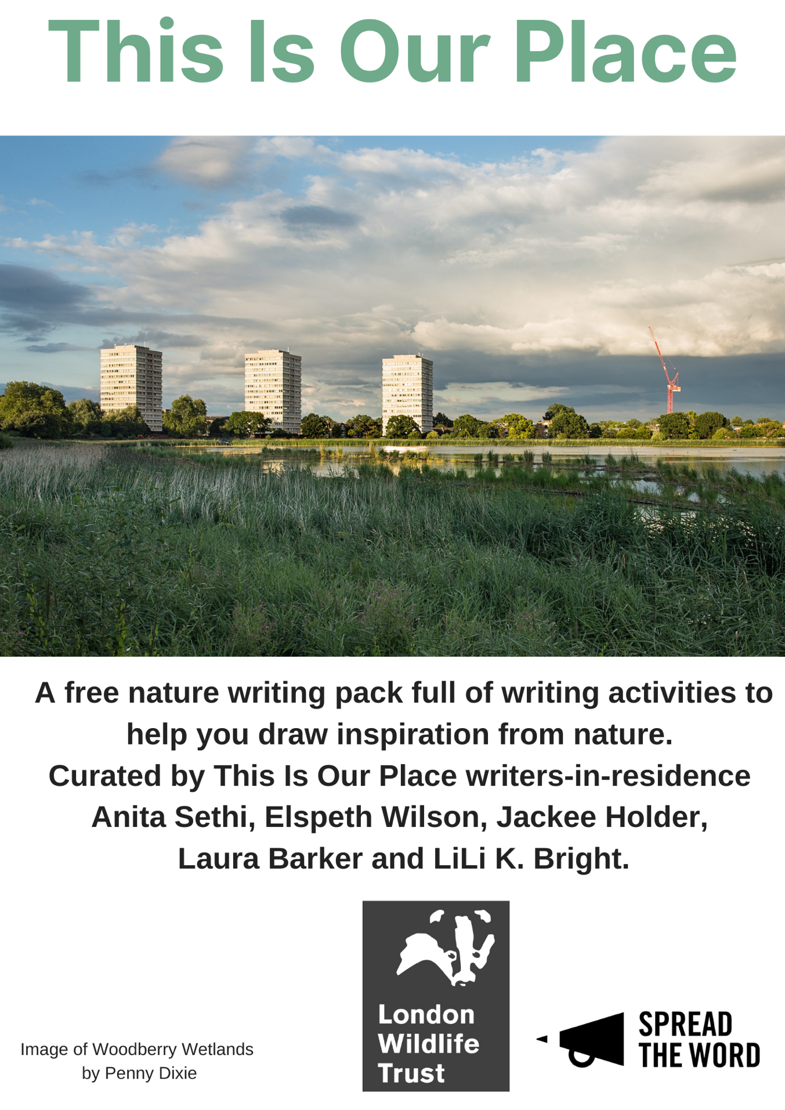
Introduction and Contents
This nature writing pack has been developed as part of This Is Our Place, Spread the Word and London Wildlife Trust’s nature writing project that exists to reimagine how we live in London and reflect on our individual and collective relationship to nature and place. It has been created to offer you an opportunity to write about nature in your own space and time; even if, and especially if, you cannot leave the house. The exercises and readings have been curated by the project’s writers-in-residence.
Take your time and enjoy these creative challenges at a time that suits you, in a space that suits you. You don’t have to live in London to take part in and enjoy these exercises.

If you’d like to attend a This Is Our Place workshop, they’re running throughout August 2021. There’s more information here: www.spreadtheword.org.uk/this-is-our-place-nature-writing-workshops-open-for-booking/

If you’d like to post any of the work or exercises on social media, please do and use the hashtag #ThisIsOurPlace.

- Writing About Nature from Home by Elspeth Wilson p.3-10
- Laura Barker and LiLi K. Bright p.11-18
- Writing Trees by Anita Sethi p.19-23
- Earliest Memories of Trees, Autobiographical List of Trees by Jackee Holder p.24-32
Writing About Nature From Home
By Elspeth Wilson
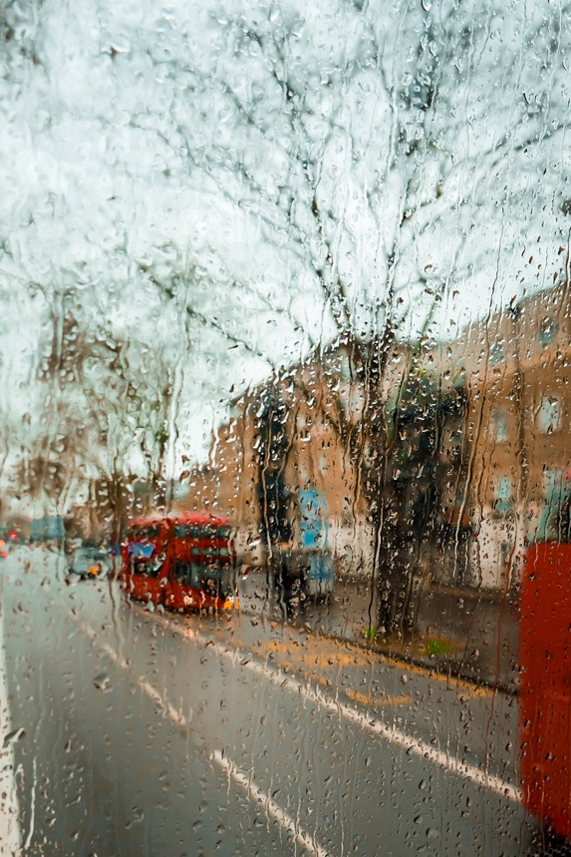
All of the following exercises can be done from your own home and don’t require you to go out or have access to any outdoor space. All you need is about fifteen minutes per exercise (although this is a suggested guideline and you can adapt them to whatever works best for you), something to write or audio-dictate with and a sense of curiosity!

This piece by Josie George is beautifully written and allows us a glimpse into the author’s world and the world around them from what we see from their doorstep. It shows us how we can consider important themes and go on emotional journeys in our nature writing without having to travel further than our own home. In some ways, nature writing that draws on the everyday and the domestic can be more relatable as so many of us don’t have immediate access to outdoor space or a garden; for us, nature might be hearing the birdsong from our top-floor flat or watching a neighbour’s cat.

Box by Josie George
https://www.bimblings.co.uk/2019/10/24/box/
On the hardest days, in the evening dark, before I’ve closed the curtains or the blinds, I like to put my shoes on and go and stand outside my house. I shut the door behind me to stop the heat running out like pennies down a pipe.
I have felt trapped lately. I’m better off saying it. My trips out into my small territory are being pulled shorter while my desire to wander grows. I haven’t left my neighbourhood in months. As soon as I leave, even in my wheelchair, energy begins to pour out and is soon spent, and the sensory clamour of everything rushes in to fill its place until I am nothing but pain and noise and crumple and I have to go home again too soon and lie still for a 100 years, watching whatever it is that I’ve inadvertently gathered to myself slowly recede, as if I’m the moon and the tide and the beach all at once.
It’s ok. It’s no big deal and will change again because all things change. I have always lived within a small permitted square of expanding and retreating size and I am used to hard edges.
My terrace pushes up tight against the road — there are no front gardens here — and the pavement is narrow, so to get a good view of what I’m looking for, I must carefully step down into the dark gutter for a moment, leaning on my sticks. I hope a car doesn’t come. It smells of leaves and old water and engine oil. The streetlights cover everything with orange film.
I live in the town centre so to stand out after sundown is to hear traffic flow, siren wail, crossing beep, anti-social shout and challenge, all pulsed by the thrum of the air conditioning units in the nursing home eight doors down. Sometimes, inexplicably, there falls a minute where none of these sounds intrude at all and I will hear instead the soft roar of a train across the distant marshland, or, if it’s Wednesday, the peal of bells from the big church a mile away. Sometimes there is nothing but blackbird, like a prayer in the night.
In front of me, a darkly-mirrored row of terraces stand; three conifer trees behind them; a dead-end street edged by leaning fencing and warped gates; a strip of tired green verge holding black tire marks. I will look at them a little while: long enough to feel the distance stretch from my feet in every direction, to send my mind out after, racing down the one-way streets and over barbed wire, tunneling through earth under the bypass and its stream of light — out, out into the world — long enough to stand and sigh, as dramatically as I know how, before turning back to face my house, to seek out my own narrow strip in the terrace.
The drop-down of the kerb makes me smaller. Here again and no-where else, unobserved, I stand, child-like, looking in at the warm, lit rectangle of my front window. I look as a stranger looks.
I see a tiny, neat room shining like a candle. Books line one wall, their spines thick and enduring; smiling photos in frames of a woman and her child and her sweetheart cover another. Above the pink geraniums that sit in a trough on the windowsill, their colour muted in the gloom, I see the bright green tumble and spike of house plants. I see a soft grey blanket, fuffy with wear. I see a pile of discarded industry on a footstool — notebooks, paperbacks, a polkadotted pencil case, the zip open and ready. On the sofa, a grown version of the blonde-haired boy in the photographs is playing a computer game and laughing with his friends over headphones. I can’t hear it, but I can feel his joy as cleanly as if I put it in my mouth, his own mouth wide and happy. A black cat sits on the windowsill, yellow eyes fixed on me, waiting, testing.
I meet his gaze as I stand and I shiver. “Yes. I’d like to go there,” I think, and I hold my back firm and climb the curb and go back inside, happy, new choice made for one more night.
“Shall we have some ice cream?” I ask as I wipe my feet. My son a grins and says yes, and we do just that.

Activity 1: Observing the outside in
Suggested time: 10-15 minutes

Choose a window in your home where you can comfortably be and write. Use the outside world as your writing prompt; use all the senses available to you to describe what is going on as a jumping off point. You can focus on sights, smells, sounds, tastes, physical feelings or a mixture depending on what senses you have available to you and what you end up noticing. It doesn’t matter whether your window opens onto a park or a car park, a street or a wall – just be open to what you are experiencing and see where it takes you. In Josie George’s piece, we get a sense of a neighbourhood and are able to glimpse other lives through the vantagepoint from her doorstep.

If you can, repeat this exercise for a few days in a row, maybe at different times of day. Then read over what you have written and see if there’s anything interesting you noticed – perhaps to do with nature, perhaps not. Remember nature writing about noticing a spider on your windowpane or hearing seagulls ransack a bin is just as valid as nature writing about swimming or hillwalking. Circle a couple of things that stood out to you or you liked in your writing and use these in turn to prompt another piece or as something to explore further.

If you don’t have a window where you are or the above exercise isn’t accessible for you for whatever reason, you can use the website Window Swap to open a window anywhere in the world and do the same exercise. The website has both (optional) sound and visuals.

--

In this piece by Fran Lock, we can see how nature writing can come in all different kinds of forms; it can have fictional and/or fantastical elements and can also be from a non-human perspective. For me, the voice in this poem is so striking and I love nature writing which draws on pop culture to talk about issues like climate crisis and habitat destruction. It can be a really interesting way to approach a difficult topic and as a reader it makes me think about these issues just as much as reading a factual article does and, most importantly, I feel the shark’s rage.

Epistle from inside the Sharknado
by Fran Lock

You might call it God; might witness the weather’s
disjointed volition, and figure it biblical payback
for all your long decades of self-defeating industry:
the gases in the atmosphere, the poison in the water.
And you might stand on your lawn in your shorts,
running a scream up a flagpole; sniffing catastrophe’s
rank surfeit on the bilious air. You might, for all I
know. For all I care you could be crouching in
rainy basements, debating plague or commies with
the cans of beans; courting immortality with forward
planning until your lungs fill up with sand like canvass
punching bags. It means nothing to me, the human
world: humourless delinquencies, the corkscrew
politics of plunder and of blame; victims of this or
that, rolling a moistened eye to camera. I see you,
surrounded by dripping debris, in the local anchor’s
sallow limelight, angling and righteous. Nuke
the sharks! It will not save you. I will come again.
We will come, seismic and genderless, thick sleeves
of meat, working the humid air like a grudge. You’d
better run. You’d better equip yourself with guns,
and chainsaws, consult a TV psychic, burn your
money, shave your head, sell your kids, anything at
all. I am coming round again. We are coming,
driven by insomnia’s deficient logics, our no-
escape velocity. You will know us by the shine
of our endangered Kevlar; my exoskeletal corset
rips your fingers into kelp. You might call it God,
but it’s not God. The sky is singing with Nature’s
maniac gusto. It’s the only game in town. Come,
hurtle over the swooning horizon, stare into my
flat-screen eye, and tell me, human, it is not so.
Activity 2: Writing about the non-human
Suggested time: 15-20 minutes

Spend two minutes making a list of animals/insects that you have a relationship with in some way. These could be animals/insects that you know personally like a pet or a service animal or more general e.g. a certain type of animal like a dog. If it feels right to you, you could also list animals that you have a less positive relationship with. You can even include fictional animals as Fran Lock has in her poem!

Once you have a few animals on your list, choose one that you’re happy to spend about fifteen minutes exploring in your writing.

Then spend about seven or eight minutes writing about your relationship with the animal you have chosen. Think about what that relationship means to you, what quality it has and how you feel about it.

The final part of the exercise is to flip the perspective and write from the point of view of whatever creature you chose. Fran Lock does this to great effect in her poem where she really manages to capture a non-human perspective and voice. See if there’s any differences from the way you think about things and your way of seeing the world.

--

Nina Mingya Powles’ poem shows us the different forms nature writing can take and how we can bring other narratives into our own writing. I love this poem because it blends something everyday – listening to the radio – with something frightening and awe-inspiring and makes me think about the connection to nature we have through technology and other objects.

The First Wave
By
Nina Powles

While listening to Radio NZ coverage of the 7.8 magnitude Kaikoura earthquake, November 13, 2016
they request that we inform you immediately you are standing on soft ground
the ceiling lights are swinging in the background
the waves crash, then dissipate the first wave may not be the largest
this is a flow-on event so do not go near do not stay and watch the land
slipping it has triggered other faults like a network of nerves
and the seabed has risen out of the sea there are visible ruptures
running along the landscape this is a flow-on event
but the moon does not cause earthquakes the ceiling lights are a typical pattern
of aftershocks and they request that we inform you
you are a visible rupture running along the landscape
do not stay and watch the nerves slipping
there will be strong currents in the background
the moon has risen out of the sea the first wave crashes, then dissipates
you are standing on such soft ground

Activity 3: Nature writing from the domestic
Suggested time: 10-15 minutes
Spend 2 minutes listing all the items you have around you in your home that have a connection to nature in some way – you might be surprised by how many you have. For example, you might have houseplants or a pet but you might also have furniture made from wood or you might be wearing a T-shirt made from cotton or have fruit or vegetables in your kitchen or have a TV where you watch nature programmes. Any and all of these things can be used as a prompt to start thinking about what nature means to us and nature in domestic spaces!
Then pick one item from your list that you feel drawn to explore more and spend ten minutes free writing about it’s journey to you. Free writing just means that there are no rules other than that you don’t make any changes along the way so try just to keep going and see what happens! You can be as literal or imaginative with your chosen thing’s journey to you as you want.
In this poem, the poet uses lines coming from the radio, a domestic appliance, to talk about an earthquake which presents another way to think about a journey – how does the object you have chosen connect you to nature?
--
You have now started several pieces of nature writing from within your own home! You can repeat these exercises anytime you like and if you want to develop them further you could combine what you have written in the different exercises. For example, you could take different lines from each piece and put them together in a new order to make a poem. Or you could write a piece of prose interweaving your perspective with that of the non-human. If you’re unsure where to go next, a great place to start is by reading through everything you’ve written and highlighting things that you like or that you want to explore further.
If you can and want to, you could also repeat any of these exercises outside, using objects you find outside as a prompt or revisiting a particular place and noticing the sensory experience there on different days.

Laura Barker and LiLi K. Bright
- Reflective writing activity
(10-15 minutes)
Guidance
- Take a sheet of paper.
- Fold it in half and in half again.
- Open it up so you have 4 sections.
- Or, you can draw lines to divide the paper into 4 sections.
- Spend 2 minutes drawing a spiral really slowly and tightly in the centre of your page. You may want to try drawing it the opposite way around from how you would automatically draw it.
- Or, put on some music you find relaxing, and listen to it for a couple of minutes, you could close your eyes.
- Or, move slowly for 2 minutes, you could do this in one position, or move around a room, or in a garden.
- Write and/or draw in response to each of the following invitations, you could spend 2 minutes on each one, writing and drawing as much as you like within the time. Or, you can write and draw until you feel read to move to the next invitation.
Invitations
- What sensations are you feeling? What’s happening in your body?
- What are you feeling emotionally? What is on your heart?
- What are you thinking? What’s on your mind?
- What else feels important?

- Look over your page, and circle, underline or highlight what stands out to you. Is there anything that moves you or surprises you?
- If you have 5 minutes more and a writing partner or a few friends (or strangers), you can share your reflections with each other.

Spiral Journal is a Liberating Structure in Development, inspired by Lynda Barry.

Liberating Structures are a collection of tools for better interactions, curated by Henri Lipmanowicz and Keith McCandless.

Here’s where you can find out more: brightlyk.com/ls

- Selected reading extracts

I could hand you a braid of sweetgrass, as thick and shining as the plait that hung down my grandmother’s back. But it is not mine to give, nor yours to take. Wiingaashk belongs to herself. So I offer, in its place, a braid of stories meant to heal our relationship with the world. This braid is woven from three strands: indigenous ways of knowing, scientific knowledge, and the story of an Anishinabekwe scientist trying to bring them together in service to what matters most. It is an intertwining of science, spirit, and story— old stories and new ones that can be medicine for our broken relationship with earth, a pharmacopoeia of healing stories that allow us to imagine a different relationship, in which people and land are good medicine for each other.
— from Robin Wall Kimmerer Braiding Sweetgrass: Indigenous Wisdom, Scientific Knowledge and the Teachings of Plants (Milkweed Editions: 2013) p. x

oh great mystery (a prayer to the blue moon on the day of the dead)

[read out loud to make into spell, or listen to me read with a lit candle]

oh great mystery
we need your help right now
for we are in an impossible situation
which we must survive
— from adrienne maree brown: oh great mystery (a prayer to the blue moon on the day of the dead) (online: 31 October 2020)
https://adriennemareebrown.net/2020/10/31/oh-great-mystery-a-prayer-to-the-blue-moon-on-the-day-of-the-dead/
https://www.instagram.com/tv/CHBMPkYgTi7/?igshid=1xrdx4pq28j51

A yellow wind stirred the leaves. Branches cracked. An animal cried out. The black cat, eyes aglow, ran past me in the direction Dad had gone. It looked back at me once. I waited. Noises accumulated in the forest. An owl flew over my head and watched me from a branch. I heard footsteps approaching and I could have sworn that they belonged to a heavy man, but when I looked I saw an antelope. It came up to me, stopped near the pole, and stared at me. Then it came closer and licked my feet. When a branch cracked amongst the trees, the antelope started and ran off. I waited, motionless. It began to drizzle. Water flowed down the invisible paths of the forest and collected at my feet. Again, I heard converging footsteps all around me. Then I saw something move. The air swelled.
— from Ben Okri The Famished Road (Vintage: 1992) p. 38

Spectra of Birds
in order of the most open
to the most closed
these are our birds
with beaks like milk carton spouts
shake before opening
— from ‘Spectra of Birds’, Ellen Van Neerven Comfort Food (University of Queensland Press: 2016) p. 65

Your grandmother names his fingers after seasons -
index finger, a wave of heat,
middle finger, rainfall.

Some nights his thumb is the moon
nestled just under her rib
— from ‘Grandfather’s Hands’, Warsan Shire teaching my mother how to give birth (mouthmark series: 2009) p.11

- Writing prompts for indoor writing: Prompts inspired by circles of life

You can use the guidance from the Spiral Journal activity, or feel free to use these prompts in whatever way you like. Follow what speaks to you and see where it leads!

Cuckoo Bees
Cuckoo bees, also called cleptoparasitic bees, don’t go hunting for pollen. They wait around for other solitary bees to do it instead. The unfortunate pregnant solitary bee makes a wax pot that she spits nectar into. She puts pollen she has taken into a kind of bed in a wax cell. When she is ready she lays her eggs onto the bed of pollen and sits on them to warm them, drinking her honey from her pot of nectar. Then the cuckoo bee comes along. Sometimes the cuckoo bees kill the queen, sometimes they kill the queen’s eggs, and sometimes they leave the eggs for their own young to eat once they have hatched into larvae. The cuckoo bee takes off soon after she’s laid her eggs and looks around for another nest.
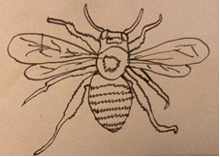
(Image description: black on ecru line drawing of solitary mining bee)

Writing prompt:
You are the pot of wax. What do you see when the cuckoo bee arrives?
Suggested time: 5 minutes

Naked Mole Rats
Naked mole rats are burrowing rodents who live in East Africa. They live under grassland. They are eusocial, meaning they live in hive-type communities like termites and ants. Only one queen and up to three naked mole rat males reproduce, and all the other naked mole rats are ‘workers’. The workers take care of the babies, find food, keep the tunnels working, protect the tunnel network from the outside, and groom. It is believed naked mole rat queens make naked mole rat workers care for the babies with their poop. Naked mole rat poop contains hormones that encourage the worker naked mole rats to take care of the babies when they eat it. It’s common for rodents to eat rodent poop. Naked mole rats are sometimes eaten by snakes.

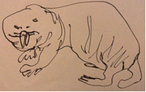
(Image description: black on ecru line drawing of naked mole rat)

Writing prompt:
You are a naked mole rat worker. What do you dream about at night?
Suggested time: 10 minutes

Zombie Ant Fungus
Ophiocordyceps unilateralis is a fungus that infects ants. It usually lives in tropical forests. The fungus sticks to the outside skeleton of the ant and gets into the ant using pressure and special enzymes. The fungus spreads into the ant’s body. The fungus makes the ant shake, and this leads the ant to fall out of its nest. The fungus grows inside the ant, in the end killing it and coming out of the top of the ant’s head.

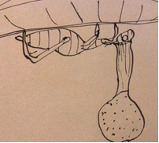
(Image description: black on ecru line drawing of ant on the underside of a leaf with fruiting body of Ophiocordyceps unilateralis sprouting out of its head)

Writing prompt:
You are the Ophiocordyceps unilateralis fungus. Which ant do you choose to sprout out of and why?
15 minutes

Aphid farms
When aphids feed on plant sap, a sugary liquid called honeydew comes out of their anuses. Ants like honeydew so much they sometimes farm aphids to make more honeydew. They take care of the aphid herd, fighting off things that will eat aphids like ladybirds and parasitic wasps. The ants also eat any aphids that are ill. When the herd is managed by ants, more honeydew is made. The ants eat the honeydew and take it back to their nests where they spit some of it back up for the rest of the ants, and the larvae.
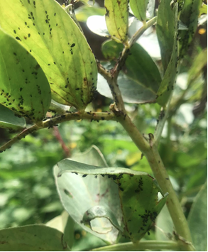
(Image description: colour photo of ant managed aphid farm on broad bean leaves and stem)

Writing prompts:
  - Write a list of words about fungus
  - Write a list of words about ants
  - Write a list of words about aphids
  - Write a list of words about honeydew
Put the words together like this:
  - A fungus word, an ant word
  - An aphid word, a honeydew word
  - Another fungus word, another ant word
  - Three more honeydew words

Suggested time: 20 minutes

- Writing prompts for outdoor writing
Feel free to use these prompts in whatever way you like. Follow what speaks to you and see where it leads!

Abundance
The world has plenty in it. Not just one kind of bean, twenty thousand kinds. 400,000 types of beetle, and deep sea spider crabs twice the size of humans.
Activity: Find five leaves, five sticks, five blades of grass, five cobwebs, and one tree that you like.

Writing prompt:
You are one of the items you have found. Give yourself a name and list your hopes and dreams.
Suggested time: 5 minutes

Plants in cracks
Some plants grow really well in cracks in concrete, like dandelions, creeping buttercup, and mercurialis.
Activity: Find a plant in a crack.

Writing prompt:
How do you feel about the concrete you are growing through?
Suggested time: 10 minutes
Night feelings
It’s hard to see stars in the London night sky because of light pollution and pollution-pollution.
Activity: Look into the night sky

Writing prompt:
  - Write a list of words about smog (like, ‘orange’, ‘smelly’, ‘polluted’)
  - Write a list of words about stars (like, ‘glittery’, ‘silver’, ‘suns’)
  - Write one line of smog words, followed by one line of star words (like, ‘orange, smelly, polluted. Glittery silver suns’). Carry on if you want to.
Suggested time: 15 minutes

Soil
Many climate scientists and activists believe there are only sixty soil cycles left (meaning there will be no topsoil in 60 years), because of soil erosion, deforestation, intensive farming, and global warming. Others think it’s more like 30 years.
Activity: Get a stick and poke it into some soil

Writing prompt:
  - Write a list of words (or numbers) or phrases about the number 60 (like, ‘50+10’, or ‘the number of seconds in a minute’)
  - Write a list of words or phrases about soil (like, ‘wet’, ‘brown’, ‘full of worms’)
  - Put a 60 word or number or phrase, with a soil word or phrase (like, ‘the number of seconds in a minute, wet, 50+10, full of worms’). Add more words if you like, or keep it simple. Finish when you’ve run out of words or phrases or numbers.
Suggested time: 20 minutes

Writing Trees
By Anita Sethi

Trees have forked their way through literature for centuries, from classic works by those including Thomas Hardy, Robert Frost and Sylvia Plath to newer works – and I hope these writing exercises will give you the inspiration to add to that canon. To help with writing, looking can also prove inspirational and my article, ‘In Praise of Trees’ collates some of the finest arboreal artwork: https://artuk.org/discover/stories/in-praise-of-trees-a-look-at-arboreal-art.

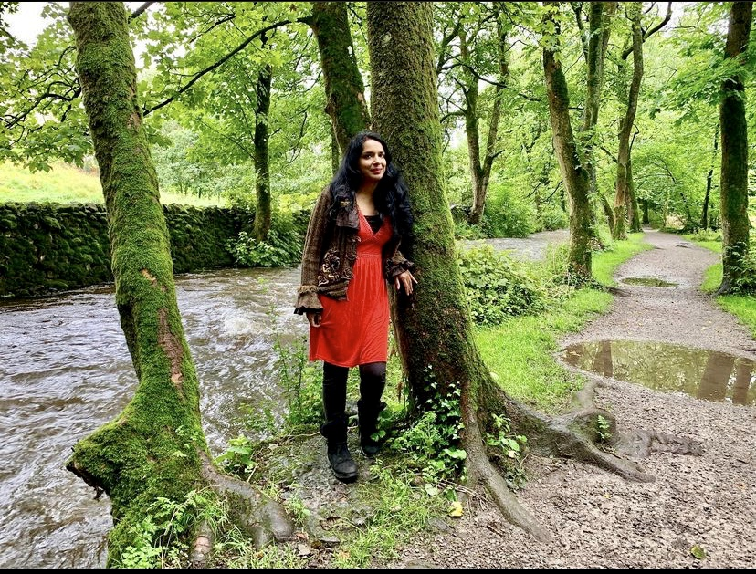
Writer-in-Residence walking beside sycamore trees in Yorkshire.

Writing Exercises

- Trees and the Seasons

Trees are a wonderful way to help us be attuned to the changing seasons – watching out for the first buds to appear then blossom and flourish into fine flowers, then the leaves turn burnished and golden and fall, leaving haunting bare winter branches.
For those who can get outside: Write for 10 minutes about a tree near you capturing how it shows what season we are in now. What flowers and wildlife can you see on the branches? At what stage of growth are the leaves? Are there an abundance of birds nearby? Pick your time carefully, too – for example, if you’re an early bird you may catch the dawn chorus!

Those who can’t get outside: what are your most powerful memories of trees associated with seasons? Do you most love trees in winter laden with snow upon the branches? Or in Summer when full of pink blossom? Or in autumn when the leaves are beginning to fall?
Winter Trees
By Sylvia Plath
The wet dawn inks are doing their blue dissolve.
On their blotter of fog the trees
Seem a botanical drawing --
Memories growing, ring on ring,
A series of weddings.
Knowing neither abortions nor bitchery,
Truer than women,
They seed so effortlessly!
Tasting the winds, that are footless,
Waist-deep in history --
Full of wings, otherworldliness.
In this, they are Ledas.
O mother of leaves and sweetness
Who are these pietàs?
The shadows of ringdoves chanting, but chasing nothing.
From: https://hellopoetry.com/poem/728/winter-trees/
- Tree of Life

The Trees, by Philip Larkin
The trees are coming into leaf
Like something almost being said;
The recent buds relax and spread,
Their greenness is a kind of grief.
Is it that they are born again
And we grow old? No, they die too,
Their yearly trick of looking new
Is written down in rings of grain.
Yet still the unresting castles thresh
In fullgrown thickness every May.
Last year is dead, they seem to say,
Begin afresh, afresh, afresh.
This is one of my all-time favourite tree poems and fills me with hope and optimism. As we emerge slowly from lockdown, what are the emotions that looking at trees conjure in you? There’s something about the incentive at the end to “begin afresh, afresh, afresh” which is wonderfully forward-looking. I’ve called this writing exercise ‘tree of life’ as it’s interesting to think of the long symbolism trees have taken on as life-givers in different cultures, garnering symbolic and emotional power.
For those who can get outside: as you walk near trees, pay close attention to your inner landscape, too: how are the trees making you feel? Hopeful? Joyful? Optimistic?
For those staying inside: Close your eyes and think of a memory of a tree and focus on how it made you feel. Then get those feelings down on the page along with painting a picture in words of the trees. This writing exercise helps you become aware and attuned to how outer and inner landscape are connected.
- Saving the Trees

The Trees are Down
By CHARLOTTE MEW
—and he cried with a loud voice:
Hurt not the earth, neither the sea, nor the trees—
(Revelation)
They are cutting down the great plane-trees at the end of the gardens.
For days there has been the grate of the saw, the swish of the branches as they fall,
The crash of the trunks, the rustle of trodden leaves,
With the ‘Whoops’ and the ‘Whoas,’ the loud common talk, the loud common laughs of the men, above it all.
(…)
It is going now, and my heart has been struck with the hearts of the planes;
Half my life it has beat with these, in the sun, in the rains,
In the March wind, the May breeze,
In the great gales that came over to them across the roofs from the great seas.
There was only a quiet rain when they were dying;
They must have heard the sparrows flying,
And the small creeping creatures in the earth where they were lying—
But I, all day, I heard an angel crying:
‘Hurt not the trees.’
From: https://www.poetryfoundation.org/poets/charlotte-mew
Hurt not the trees. A powerful line to end the poem above. In this writing exercise, I’d like you to focus on how trees are being treated by humans – how humans are variously harming trees or helping them to heal. A walk through London showed me trees with bright ribbons tied around them near Euston station from campaigners against the chopping down and destruction of trees to build hi-speed railways. For those who can walk around the city, look at the trees you can see but also look at spaces you think new trees could be planted. Think about how the city could become a greener, cleaner space with more nature given space within it. For those who can’t go outside, think about examples of trees being hurt, harmed, cut down unnecessarily or destroyed through pollution and climate change – and write about how that makes you feel. Write about your hopes and dreams for a post-lockdown world in which trees flourish – in cities as well as in the countryside.

Each and every one of us needs to breathe oxygen created by trees to stay alive at all, an incredibly equalising thing to remember. Also worth remembering is that the paper upon which you write, the books that you read – and will one day write – are also made of trees, truly a source of life which deserve to be honoured in literature.

EARLIEST MEMORIES OF TREES
AUTOBIOGRAPHICAL LIST OF TREES by Jackee Holder

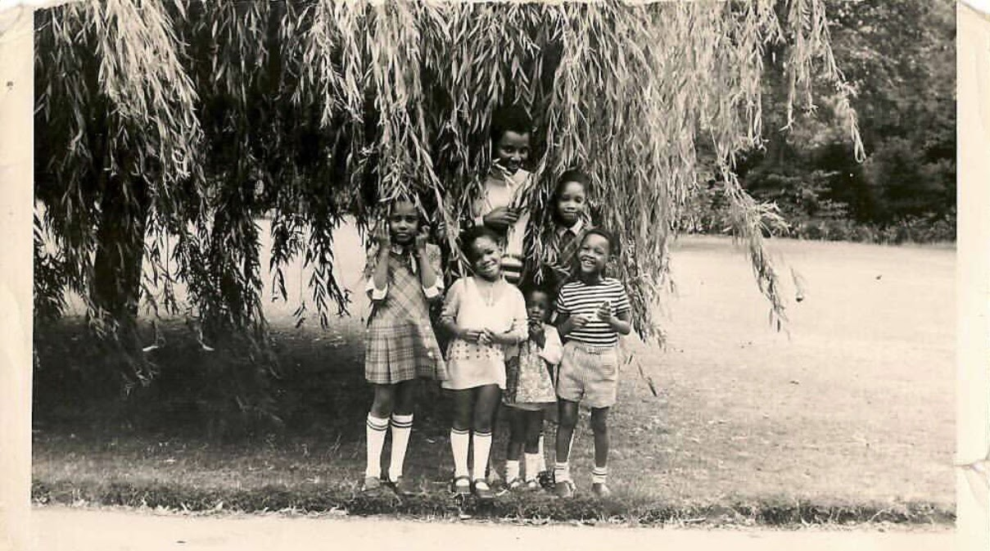
Family favourite Weeping Willow Tree in Chiswick, London in the 1970s. (Copyright Granted 26.06.21)

We start at the beginning with stimulating our earliest memories of trees. Trees are great at staying in the distant landscapes of our memories until we set the intention to bring the trees from our past into sharp focus.
I think of many trees as shapeshifting through our lives, silent witnesses, quiet observers, keepers of stories, her and his, they or as my mother once turned to me and said about the Tamarind tree she grew up with, ‘That tree had nought secrets.’
This writing activity can be done from the comfort of your own home perhaps whilst you are sat at your kitchen table or you’re relaxed on your sofa. If you are able to get out into nature a walk amongst trees can be a great stimulus for this activity. Make sure you have a notebook pen or pencil to hand.
I love lists, in creative nonfiction writing a list can be an easy and accessible place to begin almost any writing activity. Lists are great in nature writing. It requires very little effort on your part, just a generative remembering. No need to force anything.
I find that the longer you give this activity the more tree memories come to mind. Set aside 30 minutes to begin and go for longer or try out the exercise over a couple of days.

The way you approach your list can be fun too. You might want to start by drawing a tree in your notebook. The meditative rhythms of drawing or sketching allows the right side of the brain to relax allowing tree memories to flood through your imagination with least effort on your part. If you’re writing indoors you might want to start right there. Or perhaps there are trees in the background like the one above from my friend Suzette Llewellyn that feature in old family photographs.
If you’re writing outside in a green space you might start by sketching or taking a photograph of the trees in your location. You are generating what I refer to as my autobiographical tree list. There’s a few ways you can access this list. One way to start your autobiographical tree list is by listing various locations you have lived at throughout your life. This could be listing as many countries, towns, cities, villages or door numbers you’ve lived at during your lifetime. Next list the trees you remember from each location. This is by far the easiest way to remember. If you don’t know the botanical name of a tree, name it yourself.
When I first connected to that early memory I had no idea of the botanical names of the trees. But when I researched many years later about the trees that populated this region of London I imagined I was sat under the watchful eyes of Bulging Beech trees or towering Elms before they were taken out by Dutch Elm disease.
Whilst this is not a direct extract from nature writing this list from Jamaica Kincaid’s Girl, includes reference to nature from her mothers instructions which she captures in a list. The rhythm and pace of the list brings alive the spirit of list making as both generative and fertile for bringing together those early memories and first thoughts around the trees. Jamaica Kincaid is a great nature writer and a lover of gardens and you might like to read some of her books including, Among Flowers and My Garden (Book).
“ … this is how you grow okra – far from the house, because okra tree harbours red ants: when you are growing dasheen, make sure it has plenty of water or else it makes your throat itch when you are eating it, …”

PEN PORTRAITS OF TREES
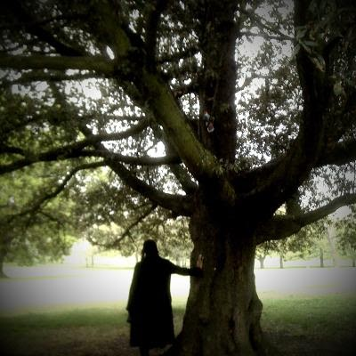
Jackee Holder with one of the trees from her Autobiographical Tree List 2001
Now you should have several trees populating your list. Next choose any one tree from your list. It does not need to be a notable tree and you don’t need to have a really strong memory of the tree. This writing activity can be carried out indoors or outside. Don’t worry about the quality of remembering connected to each tree for now. Part 2 of this writing activity will help you bring more of your memories of the trees to life.
Let me introduce you to the idea of crafting a pen portrait of your chosen tree. This is a more detailed description of your tree and includes bringing in feelings and emotions and more sensory detail. For your pen portrait try writing it in three 10-minute chunks over the course of the day.
To support this writing activity I would like to introduce the concept of Palimpsest. I first came across this concept over twenty years ago when it was attributed to the ancient Egyptians writing over writing on papyrus rolls. Think of Palimpsest as layering or re-using your writing. Working with your pen portrait the first 10 minutes is the zero draft of your pen tree portrait. You are laying down the bones. Then your next 10 minutes you layer over that first version or simply add to it. The idea with Palimpsest is that not all of the writing is erased. By the third writing practice you will know what parts of your pen portrait you want to hold onto.
Here are some writing prompts you might work with whether you are free writing or trying out the writing prompts below.
Describe the tree’s shape, height. What colours radiate from the tree, what are the textures of the tree’s bark? Imagine the smells and aromas associated with the tree? Smell is the oldest and most primal of the senses and one of the senses that are easily overlooked.
Where is your tree located? What year is it? Don’t know, make it up. How old were you in the memory? How long has the tree lived here? What does the tree know of this place that is not known to you? What was going on in the background? Play with a close-up lens on your tree and then zoom out to explore what else was going on at the time.
Next pay attention to a moment with the tree. Maybe it was an incident. The first time you climbed the tree. I recall a podcast interview where I was asked a question about how I came to love and work with trees in my work as a coach and facilitator. It ended with the interviewer remembering a buried memory of a time as a young girl when she would climb onto a high branch on the towering Beech tree in the family back garden. For weeks no one knew she was hidden away in the tree.
As she recounted the memory the pace of her voice slowed down, and the pauses grew longer on the phone line. I could literally feel her breathing in her power and strength as a young nine-year-old girl from the other side of the phone line. I waited with baited breath as she remembered, ‘I became the Beech tree and the Beech tree became me.’ A faint memory was not light in content. She had connected with her resilience through an existential moment of remembering how powerful she felt hidden away amongst the beech trees, stout branches and whistling leaves in the wind.
Perhaps your early memory is located in taste, the first time your mouth melted into the soft flesh of a sweet peach from the tree. Whatever moment you choose to write into gives it a clear focus on the page. Your moment could have lasted for five minutes or five hours. Captured moments (Adams. K. 2013) takes precedence over time.
In an essay for Project Mindful Magazine, ‘My Love Affair with Trees’, I introduced one of the trees from my autobiographical list of trees, that went from a pen portrait, into being featured in essays and eventually into a book, ‘For some time I continued regular early morning visits to Sanctuary, the name I gave my tree. It became my sacred place in nature, like the sanctuary of the altar in cathedrals. And beneath the tree’s canopy became my place for ceremony and ritual.
Early morning appointments when only the hardy dog walkers were out would almost guarantee I would have the tree to myself. Sometimes I would lean my back against the tree's crinkled bark, allowing my weariness to drain away like leaves falling to the ground, believing that in some way the strength of this tree would find its way into my body. Trees’ trunks are shaped like our own bodies, their legs resembling our arms and their roots, the legs we walk and stand on.
Other times I would perform a body prayer taught to me during seminary training and on other occasions I would give the tree a hug or sit close by and journal.’
Don’t be afraid to allow the memory to write itself. The extract below from a Carl Phillips essay is both intimate and provocative. It questions both the necessity and the difficulties of black people’s cultural remembering of the trees. Notice how he focuses on the detail of remembering and then zooms out with a wider lens and leaves the question hanging in the air. He brings in the concept of loneliness and introduces us to his father’s character through the tree.
‘My earliest memories of trees is of a particular fig tree in the yard of the first house I remember, in Portland, Oregon. I was five, at the most. Sometimes what I remember is playing in the shade of it, and at other times the bees that seemed to bloom from inside the windfalls—though it seems now to have been less the wind that brought the fruit down but the weight of ripeness itself, as if sweetness, too much sweetness, meant mistake, punishment therefore; for hours, I’d watch the bees enter and leave the split-open sides, and how the figs looked lonely, once the bees had gone, as if to be plundered meant at least not being alone …
One evening, instead of coming inside when called, I climbed the fig tree, wearing only a tee shirt and underpants. It seemed like a game, to be up in the tree, and my parents not able to find me, calling my name as they wandered the yard. And then somehow, I fell, and then suddenly stopped falling: my underwear had caught on a branch, saving me from hitting the ground, but holding me in mid-air, unable to get down. The way I remember it, my mother told my father to get a ladder.
What’s very clear in memory is my father saying I should hang there in the tree for a bit, to learn a lesson about disobeying my parents.’
‘Among The Trees’, by Carl Phillips, April 20, 2020. Emergence Magazine.
PATHETIC FALLACY
We are closer to trees than we could ever imagine. In the opening lines of her poem about her grandmother the Scottish writer and poet Jackie Kay begins the poem with the lines:
‘My grandmother is like a Scottish Pine, tall straight backed, proud and plentiful, a fine head of hair, greying now. Tied up in a loose bun. Her face is ploughed land. Her eyes shine rough as amethysts.’
That Distant Apart, 1991 Tanet Books
Below are the photos of a palm tree I often walk pass on my early morning walks that prompted this piece of writing about my grandmother.

‘My grandmother is like a husky Palm tree. Her bark is hard and tough, impossible to penetrate. She is surrounded by walls not easy to climb. In the summer months when the sun is hot and steamy although she has leafy green foliage she chooses not to shelter me, her granddaughter but leaves me outside in the sweltering sun whilst she calls my two brothers into the cool of her shade.’

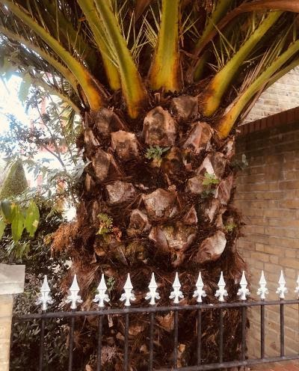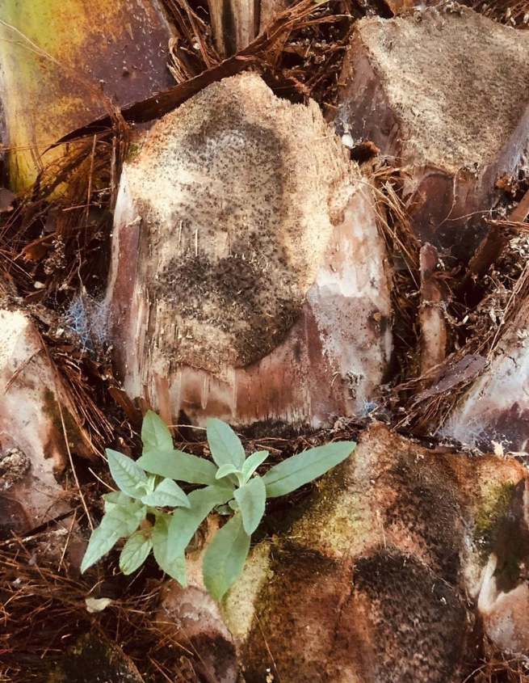

Pathetic Fallacy is a writing concept which embodies nature as a character. It's a way of using the richness of metaphors and images of trees or plants in nature to bring characters to life.
Remember you don’t have to go out into nature to be inspired. This writing exercise can be done from the comfort of your home as previously mentioned but equally can equally work well with you walking and writing outdoors.
According to a study at the University of Illinois looking at images of trees is enough to boost your mood positively. If you are working indoors why not look at a few images of trees online to take in all the varied physical characteristics trees carry. If you are out in nature use the naked eye as your camera and do the same.

So much of a tree’s physicality resembles a human body. The roots of a tree, our feet, the trunk, our torso, bark our skin and the branches and leaves mirroring the upper half of the body. Once you start noticing and interacting with the trees you will start to see them as people or see images of people in the trees.

Describe someone you know or a character through the eyes of a tree, plant, stone or landscape drawing inspiration from nature. Start with the line My grandmother or my mother … or simply start with the person or character's name. Play with using images from nature to speak to a strong feeling or emotion without naming the topic upfront to begin with. Set aside 15 minutes for the first part of this writing activity.
In this extract Rue Mapp the founder of Outdoor Afro had this to say about nature:

‘The trees don’t know what colour I am
The birds don’t know what gender I am
The flowers don’t know how much money I have in my bank account
I can rely on nature to be the equaliser so we can shed that weight.’

Rue’s words use nature to shape her character and her feelings about being an African American woman tag this time. She is particularly aligned to championing access for people of colour spending more time in nature.

I’m curious about how Rue’s words impact you? How about taking your thoughts and feelings in response to her comments into a second 15-minute free writing exercise. That means anything goes. You allow the writing to come freely without censorship. This is an opportunity to unearth your own relationship or non-relationship with nature and society at large. Here’s a prompt for those of you not sure where to start: What do I think of what Rue has to say, So what does this mean? Now What will I do?

Both extracts use nature as a way into the conversation about race and racism. Writing about nature does not need to be all about existential highs. Writers from diverse backgrounds can mean taking the filters off of nature writing and writing about what is not seen, what is ignored and what is not known. Use the writing prompt to root into the shadowlands of your lived experiences and bring them to light without apology.

This Is Our Place is a partnership project between Spread the Word and London Wildlife Trust, funded by the Emergence Foundation.
About Spread the Word
Spread the Word is London’s writer development agency, a charity and a National Portfolio client of Arts Council England. It is funded to help London’s writers make their mark on the page, the screen and in the world and build strategic partnerships to foster a literature ecology which reflects the cultural diversity of contemporary Britain. Spread the Word has a national and international reputation for initiating change-making research and developing programmes for writers that have equity and social justice at their heart. In 2015 it launched, Writing the Future: Black and Asian Writers and Publishers in the UK Market Place. In 2020 it launched Rethinking ‘Diversity’ in Publishing BY Dr Anamik Saha and Dr Sandra van Lente, Goldsmiths, University of London, in partnership with The Bookseller and Words of Colour. Spread the Word’s programmes include: the Young People’s Laureate for London, the London Writers Awards and the national Life Writing Prize.
www.spreadtheword.org.uk
About London Wildlife Trust
London Wildlife Trust is dedicated to protecting, conserving and enhancing the capital’s wildlife and wild spaces. Our vision is of a London alive with nature, where everyone can experience and enjoy wildlife. Founded in 1981, the Trust manages 37 free-to-access nature reserves across the capital and engages with London’s diverse communities through practical land management, campaigning, volunteering and education in order to give London’s wildlife a voice. They work with many partners to advocate for a city richer in biodiversity and ecological resilience, through policy, planning and best practice. The Trust is one of 46 Wildlife Trusts working across the UK, with the support of over 800,000 members and 40,000 volunteers, to make local areas wilder and make nature part of life, for everyone.
www.wildlondon.org.uk
Writers-in-residence Biographies
Anita Sethi
Anita Sethi was born in Manchester, UK. Her new book, I Belong Here: a Journey Along the Backbone of Britain is the first in her nature writing trilogy, published by Bloomsbury. I Belong Here has been described as "a thing of beauty" by the Sunday Times, "a memoir of rare power" by the Guardian, and as ‘a magnificent and redemptive achievement’ by The Bookseller. Her writing has also appeared in anthologies including Common People, The Wild Isles and Women on Nature. She has written for the Guardian, Observer, i, Sunday Times, Telegraph, Vogue, BBC Wildlife and appeared on various BBC radio programmes. Her career highlights include going birdwatching with Margaret Atwood in the UK's oldest nature reserve. Twitter: @anitasethi @ibelong_here

Elspeth Wilson
Elspeth Wilson is a writer and poet who is interested in how our identity impacts our relationship with nature, and how we can write about nature from the perspective of the everyday and the domestic. She has been shortlisted for Canongate's Nan Shepherd prize and Penguin's Write Now Editorial programme, and is currently working on her first book about nature, trauma and recovery. Her work frequently asks questions of how we live in our bodies and how we make them homes and hopes to widen the possible answers to those questions.

Jackee Holder
A well-seasoned walker of London streets, parks and green spaces with over 10,000 walking hours under her belt. Jackee is a custodian of trees gathering stories and narratives on paper and through the spoken word to keep memories of our urban woods and forests alive. Jackee is an author, coach and coach supervisor working in leadership and organisational development.

Laura Barker
Laura Barker is a writer, artist, and facilitator. She runs an LGBT black writing group in London. Her work has appeared in Apparition Lit, midnight & indigo, and The Other Stories. She has guest edited for Apparition Lit, and her YA novel Picnics was shortlisted for the Faber Andlyn (FAB) Prize.

LiLi Kathleen Bright
LiLi Kathleen Bright is a writer, workshop leader and coach, specialising in asynchronous, remote communication. With a deep love of learning, LiLi is studying German and is an amateur dendrologist. Currently creating a collection of tree poetry and short stories, they were selected for The Future is Back writing award in 2019 and have performed at Gays the Word.

