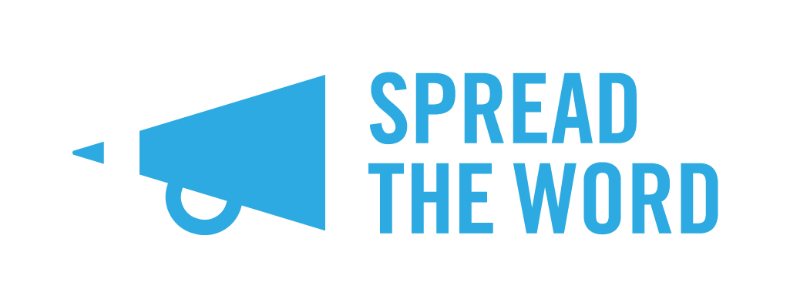

This Is Our Place 2021 Postal Entry Form
If you are entering the This Is Our Place Competition by post, please complete this short entry form and attach it to your poem (up to 30 lines maximum) or prose entry (up to 1,000 words maximum). Post it to:
This Is Our Place, Spread the Word, The Albany, Douglas Way, London SE8 4AG. If you would prefer to enter online, you can do that at:

https://spreadtheword.submittable.com/submit

Deadline for entries is 5pm on Monday 20th September 2021. Entries will not be accepted after this date.

- What is your name?

- What is the title of your This Is Our Place entry?

- Please state whether your extract is: (please delete as appropriate)

a) A Poem (up to 30 lines maximum)
b) Prose fiction or non-fiction (up to 1,000 words maximum)

- What is your email address?

- What is your phone number?

- What is your postal address and postcode?

- Please confirm that you are eligible for the Competition by ticking all the relevant boxes. Note that if any of these do not apply to you, you are not eligible to enter the Prize.
I can confirm all the following apply to me:
I live in London
I have read and agree to the This Is Our Place 2021 rules (please visit the Spread the Word website for details)
I am over 18
I belong to at least one of the underrepresented groups listed below

I attended the following This Is Our Place workshop:
(e.g. Elspeth Wilson Online 6th August)

8. Please help us monitor and develop the Competition by letting us know which underrepresented group you belong to (you can tick more than one box):
Disabled LGBTQIA+ Working Class Writer of Colour*

*Black, Asian, Arab, Mixed-Raced and Non-white Latinx
Spread the Word will be in touch with all entrants in October 2021. Please note we are not able to return entries, but we will acknowledge receipt.

