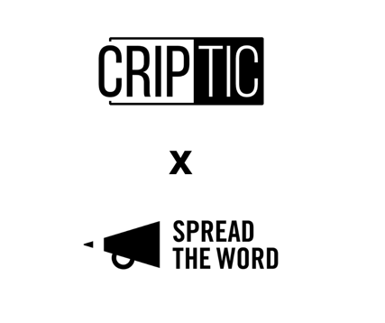

Access to Literature: Survey for organisations

This survey is for literature organisations, funded and non-funded in the UK, including but not limited to organisations who work primarily with and for writers and poets and/ or who develop programmes of activity and content for readers and wider audiences.

The survey forms part of CRIPtic Arts’ and Spread the Word’s Access to Literature research work which aims to understand the barriers to access in the literature sector for D/deaf and disabled writers and audiences and how we can improve access to programmed opportunities both in person and online.

Through providing your feedback we will be able to start to build a data and evidence base to support change and the opening up of opportunities for D/deaf and disabled writers and audiences.

The survey will run until: Tuesday 21 September 2021, 5pm

The research will result in a report of the findings, online sharing of best practice and training sessions for funded organisations, non-funded organisations and individual creative practitioners.

Your personal data will not be shared and any findings used in the report will be anonymous.

If you have any questions about Access to Literature, please contact: ruth@spreadtheword.org.uk

- Contact details:
Your name:
Position:
Email address:

- Organisation details:
Organisation:
Address:
Post code:
Website:

- Please tell us what type of organisation you are:
Not for profit (for e.g.: charity, CIC)
Voluntary (i.e.: unconstituted)
Commercial business
Other (please say)

- Please tell us if you are currently in receipt of:
Arts Council England National Portfolio Organisation status
Arts Council England project grants funding
Not applicable

- Please tell us the primary areas of your work (tick up to three):
Writer development
Publishing
Agenting
Festival
Reader development
Courses
Commissioning opportunities
Events
Residentials
Mentoring
Community projects
Bookselling
Prize/s
Children/ young people work
Workshops
Other (please say)

- Please tell us how you deliver your work (tick as many as :
Online
In-person
Hybrid
Via third party (e.g.: bookshop)
Other (please say)

Do you have an access policy? Yes/ No
If yes, please provide a link to it:

- How would you rate your and your teams’ understanding of making your organisation’s work accessible to D/deaf and disabled writers and audiences? (1 = low, 5 = high)
1 2 3 4 5

- Please tell us how you currently make your work accessible:
[likert scale: Always Often Sometimes Rarely Never]
Access list for pre-bookings
Provide free spaces for personal assistants
Provide communications about your work/ opportunities in different formats (i.e: Easy Read)
Ensure accessible online communications (i.e: alt text)
Website compliant with access standards
Provide access information for event activity as standard
Captioning
Transcriptions
Live transcription
BSL interpreters
Wheelchair access
Work in partnership with disability organisations
Consult with d/Deaf and disabled writers/ creative producers
Provide staff and Board inclusion and access training
Provide workshop/ reading materials in advance of workshops/events
Build in regular breaks as part of workshop/ event timings
Provide trigger warnings (verbally/on materials/in communications)
Get information from artists/ participants on their access needs
Other (please say)

- Please tell us the three main challenges to making your work accessible to d/Deaf and disabled writers and audiences:
1.
2.
3.

- Please tell us what would be most helpful to support you in making your work and organisation more accessible:
Best practice guidance
Training specific to literature organisations
‘How to’ guides
Peer to peer learning network
Other (please say)

- If you have an example of what you consider to be good practice in terms of access to literature, please tell us about it here: [free text 200 words]

- Anything else you would like to say about your organisation’s approach to increasing access to literature and the support you may need: [free text 200 words]

- Are you happy for us to contact you about your survey responses? yes/ no
Please tell us if you would like to be entered into the draw to win £50 National Book Tokens for completing this Survey: yes / no

