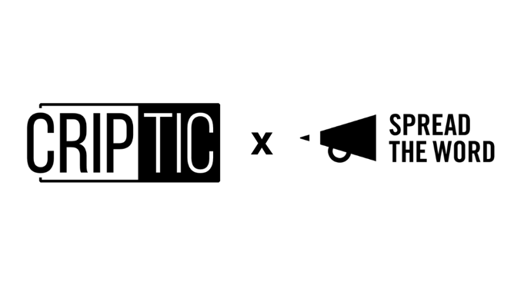

**Access to Literature:   
Survey for D/deaf and disabled writers, literature audiences and creative producers**

This survey is for D/deaf and disabled audience members of literature events and workshops and writers, poets and creative producers developing their craft and career in the literature sector in the UK.

The survey forms part of CRIPtic Arts’ and Spread the Word’s Access to Literature research work which aims to understand the barriers to access in the literature sector for D/deaf and disabled writers, poets and audiences and how we can improve access to programmed opportunities both in person and online.

Through providing your feedback we will be able to start to build a data and evidence base to support change and the opening up of opportunities for D/deaf and disabled writers, poets and audiences.

**The survey will run until: Tuesday 21 September 2021.**

The research will result in a report of the findings, online sharing of best practice and training sessions for funded organisations, non-funded organisations and individual creative practitioners.

Your personal data will not be shared and any findings used in the report will be anonymous.

If you have any questions about Access to Literature, please contact: [ruth@spreadtheword.org.uk](mailto:ruth@spreadtheword.org.uk)

1. **About you**

Please tell us if you are a: (please tick as many as apply).

Writer/ poet

Creative producer

Audience member (of literature events)

Other (please say)

City/ town/ village where you live:

Your post code:

1. **Please tell us how you primarily access literature events, workshops and opportunities:**

Online

In-person

Other (please say)

1. **If you are a D/deaf and disabled writer, poet and/ or creative producer, what types of accessible activities would you like to see more of? Please select your top four.**

1 to 1 mentoring

Development programmes led by D/deaf and disabled writers/ poets/ creative producers

Publication opportunities

Industry networking opportunities

Accessible resources on for e.g.: getting an agent, careers in literature

Workshops led by D/deaf and disabled writers/ poets/ creative producers

Residencies for D/deaf and disabled writers/ poets/ creative producers

Commissioning opportunities

Sustained and local workshops/ spaces for D/deaf and disabled writers, poets and readers

Reading and performance events for D/deaf and disabled writers/ poets

Prizes showcasing and promoting work by D/deaf and disabled writers/ poets

More D/deaf and disabled writers being booked by Festivals and venues

Other (please say)

1. **If you are an audience member, what types of accessible activities/ content would you like to see more of? Please select your top three.**

Books by D/deaf and disabled writers/ poets

Accessible reading lists

Sustained and local activities for D/deaf and disabled readers (for e.g.: reading groups)

Reading and performance events by D/deaf and disabled writers/ poets

Prizes showcasing and promoting work by D/deaf and disabled writers/ poets

More D/deaf and disabled writers events run by Festivals and venues

Other (please say)

1. **If you are an audience member, please tell us what, for you, are the main barriers to accessing literature events, workshops and opportunities** (tick as many as appropriate)**:**
2. Cost
3. Events/ workshops taking place in inaccessible spaces (online and/ or in person)
4. Lack of clear information on accessibility (of events/workshops/opportunities)
5. Lack of accessible transport to venue
6. Not giving information in multiple formats
7. Lack of understanding (by the organisation) of adjustments that need to be made
8. Lack of activity near where I live
9. Not clear who to contact to ask questions about support available
10. Organisation not putting in place reasonable adjustments
11. Inaccessible sign up/ booking processes
12. Lack of spaces/ additional costs for personal assistants
13. Workshop and reading materials not being provided in advance
14. Trigger warnings not being provided (for traumatic material)
15. Lack of breaks at workshops/ events
16. Organisations not knowing how to work with BSL interpreters
17. Other (please say)

**6. If you are a writer, poet or creative producer, please tell us what, for you, are the main barriers to accessing literature events, workshops and opportunities** (tick as many as appropriate)**:**

1. Cost
2. Events/ workshops taking place in inaccessible spaces (online and/ or in person)
3. Lack of clear information on accessibility (of events/workshops/opportunities)
4. Lack of accessible transport (to venue)
5. Not giving information in multiple formats
6. Lack of understanding (by the organisation) of adjustments that need to be made
7. Lack of activity near where I live
8. Not clear who to contact to ask questions about support available
9. Organisation not putting in place reasonable adjustments
10. Expectations around social networking
11. Inaccessible application/ sign up/ booking processes
12. Lack of spaces/ additional costs for personal assistants
13. Workshop and reading materials not being provided in advance
14. Trigger warnings not being provided (for traumatic material)
15. Lack of breaks at workshops/ events
16. Organisations not knowing how to work with BSL interpreters
17. Tight deadlines for delivery of work
18. Lack of ongoing support or community
19. Delegitimizing of work (i.e.: seen as therapeutic)
20. Pacing of work in workshops/ events (i.e.: too much being covered in too short amount of time)
21. Lack of paid work (for d/deaf and disabled writers
22. Other (please say)

**7. What do you think literature organisations need to do to make themselves and their work accessible:**

1.

2.

3.

4.

5.

**8. Please tell us your experience of accessing literature events, workshops and opportunities over the past year and how you see yourself accessing them in the future:**

**9. Is there anything else you would like to say about accessing literature events, workshops and opportunities as a writer, creative producer and/or audience member:**

**10: Please tell us about a good experience that you have had in accessing literature opportunities:**

**If you’d like to be entered into a draw to win a £50 Book Token for completing this survey, please tell us your email address. We’ll remove this from your responses to ensure they remain anonymous.**