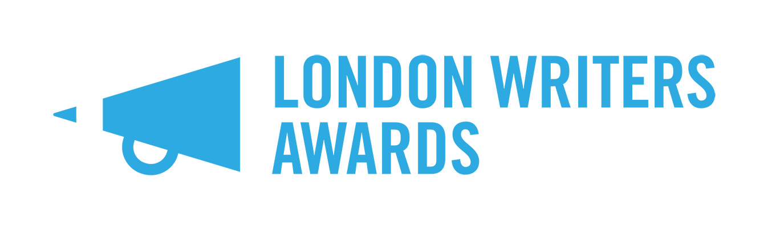
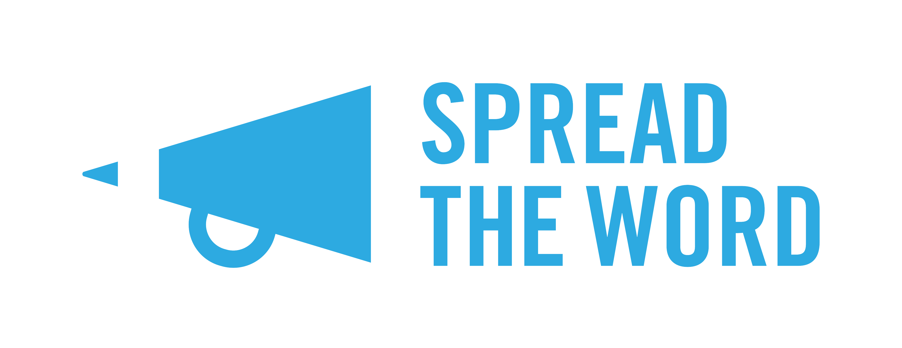
London Writers Awards 2022 – FAQs

What is The London Writers Awards?
The London Writers Awards is Spread the Word’s annual writer development programme, which offers up to 30 London writers from communities currently under-represented in publishing a ten-month programme of masterclasses, critical feedback groups, WritersLabs, 1-2-1 support and networking opportunities.

Why are you running this programme?
Building on our Writing the Future (2015) research, the London Writers Awards has been developed to address the on-going lack of opportunities available for new and emerging writers to find an agent and receive sustained professional input and quality feedback to produce work that will be published. The London Writers Awards responds to this need by putting in place an annual development programme for London’s emerging talent, with the overt objective of increasing the number of talented writers from under-represented communities being taken up by agents and publishers.

Who is The London Writers Awards for?
The Awards are for: 18+; writers of colour, working class or working class background, and Lesbian, Gay, Bisexual, Transgender, Queer (LGBTQIA+) writers, and disabled writers currently living in London. Talented un-agented and unpublished writers who are writing in one of the Award’s four categories: literary fiction (including short stories); commercial fiction (e.g. romance, crime, science fiction); narrative non-fiction and YA/children’s fiction (middle grade and YA, but not picture books). There will be two cohort groups of literary fiction writers (six people in each group).

What does The London Writers Award offer?
Successful applicants will be offered training, support and networking opportunities including:
- Participation in two critical feedback groups a month to gain valuable feedback on your project and give feedback to your fellow Awardees;
- Nine writing craft and career masterclasses with leading writers and industry professionals;
- 2 WritersLabs with talks and workshops by writers, agents and publishers and a networking event to editors and agents;
- 1-2-1 professional development support sessions with Spread the Word staff members;
- Bursaries for writers most in need;
- Access fund for disabled writers.

Do I have to pay anything?
No. Participation in the Awards is free at the point of delivery. Travel and other costs associated with participating in the Awards will not be covered by Spread the Word. There are limited bursaries available for writers most in need. There is also an access fund to support disabled writers participating in the programme.

Will it be online or in person?
At this stage we are preparing for the programme to be run online via Zoom and Slack primarily. We are also monitoring the advice from the government and will make a decision in the autumn as to the possibility of some activity taking place in person. We will keep applicants updated if there are developments.

What are the programme dates?
The selection process will be completed by the end of January 2022. The programme of activity will start on Saturday 26th February 2022 with WritersLab 1. There will be a summer break in July and August, where there will be a focus on you to keep writing your project. The programme will end on Thursday 24 November 2022 with WritersLab 2. Please note that these dates are subject to change and will be confirmed in December. We have to factor in whether activity will be online or in person in our planning.

Will it take up much of my time?
The London Writers Awards are for writers who are committed to taking their work to the next level and who aspire to being published and having a career as a writer. You will need to be available to participate across the ten months of the programme. The critical feedback groups will take place in the evening twice a month and last 2 hours each time (thirteen sessions will take place in total). You will also be expected to spend 1-2 hours reading your group members’ writing in preparation for each session. There will be five creative writing masterclasses, and four career masterclasses. These will take place on Saturdays from February 2022 to November 2022. There will also be two WritersLabs – one to open the programme on Saturday 26th February 2022, and one to close the programme on Thursday 24th November 2022. Attendance is mandatory as part of the terms and conditions of the programme. You will also need to find time to work on your writing project so that it can progress during the programme. We estimate that the programme will take up approximately 30 hours per month – please consider this carefully before applying.

What do you mean by middle grade?
Middle grade are books written for children aged roughly between 8-12 years old. They are generally 30,000 – 50,000 words in length (though fantasy can run longer). Content restrictions include: no profanity, graphic violence or sexuality. The protagonist age is typically 10 for a young middle grade novel, and up to age 13 for older, more complex books. Middle grade books tend to focus on friends, family and the character’s immediate world and relationship to it; characters react to what happens to them, with minimal self-reflection.

I write non-fiction – is this the same as narrative non-fiction and is it eligible?
The Awards are for writers of narrative non-fiction by which we mean: life writing, biography, memoir, nature writing and non-fiction with a strong literary intent. If your writing is factual, technical, scientific, journalistic, local history or travel writing it is not eligible for an Award.

How do I apply?
There are four ways in which you can apply:
- Through an online form on our Submittable page (https://spreadtheword.submittable.com/submit);
- On a paper form, which you can download from our website and post to us;
- As an audio file, which you can enter via Submittable. Please contact us if you wish to use this option;
- As a video file if you use a BSL interpreter. The file can be entered via Submittable. Please contact us if you wish to use this option.

In each option you will also need to submit a sample of your writing, which should be an extract from the project you’d like to develop as part of the programme and will be a maximum of 3,000 words. There is no minimum word count. Applications to develop individual short stories or poems will not be accepted. If you would like to submit your application in another format, please contact us to discuss.

What’s the application process?
Entries will be sifted by Spread the Word’s designated first readers. A writer and industry professional will then judge the sifted entries. Shortlisted applicants will be invited to interview on Zoom / or in person (tbc) on either 18th / 19th / 20th January 2022. Offers will be made to 6 applicants in YA/children’s, commercial fiction and narrative non-fiction and to 12 applicants in literary fiction to make a total of 30 writers winning an Award. There will also be a limited number of bursaries and access funds allocated – this will be decided when we have confirmed the 30 places on the programme.

Who are the judges?
This year’s judges are:
- Literary fiction – Louise Hare, Ashley Hickson-Lovence, Matt Turner, Milly Reilly
- Commercial fiction – Sara Jafari and Emma Grundy-Haigh
- Narrative non-fiction – Sara Gibbs and Emma Bal
- Young Adult and Children fiction – Benjamin Dean and Davinia Andrew-Lynch

Who is eligible to apply?
To apply for the scheme, you must be over 18 years of age, living in London, currently un-agented and without an existing publishing contract. You must also either a writer of colour, a working class (or working-class background), LGBTQIA+, and/or a disabled writer. You will also need to be available to commit to the ten-month long programme, which will run from February 2022 to November 2022.

Do I need to have a finished novel or project to apply?
No, but you will need to have a current work in progress that you can develop during the ten-month programme. The ultimate aim for The London Writers Awards is for each writer to end the programme with a finished novel, short story collection, or non-fiction book, which they can submit to agents and publishers. You will need to submit a sample of your writing to apply as outlined above.

I’ve done/am doing a creative writing course – can I apply?
If you are currently or are about to be enrolled in a graduate or postgraduate creative writing programme (BA, MA or PhD) or are part of a longer-term development programme for writers (such as the Faber Academy, Curtis Brown Creative, Jerwood Arvon Mentoring scheme, Penguin Random House Write Now, London Libraries Emerging Writers scheme) you are not eligible to apply. If you have previously completed a creative writing course in the last two years, you are also not eligible to apply. We have made this eligibility requirement to reach people who have not had sustained writer development.

I’m a self-published writer, can I apply?
Previously self-published writers can apply with a currently unpublished work.

Who can apply for a bursary?
The London Writers Awards bursaries are aimed at writers who:

- Carers;
- Single parents;
- Care leavers;
- Experience of being homeless;
- Ex-offenders;
- Unemployed;
- On a low income either on benefits or a minimum wage zero hours
contract.

If you consider yourself eligible for a bursary, please complete the relevant section in the submission form when submitting your application.

I have access needs what should I do?
If you are a disabled writer and have access requirements that will need to be supported for you to participate in the programme, please complete the relevant section in the submission form when submitting your application.

When is the deadline to apply?
The application window will open on Friday 1 October 2021 and close at 11.59pm, Sunday 31 October 2021. Entries submitted after the closing date will not be accepted.

What happens after I submit my application?
Spread the Word will respond to all applicants regarding the status of their application in November. Please note that due to the high number of applications we expect for this programme, we are unable to give individual feedback.

When does the programme start?
The London Writers Awards will start on Saturday 26 February with a WritersLab bringing together all the writers on the programme, judges and industry professionals. The programme will run through to November 2022.

My question isn’t listed here – what do I do?
Please also refer to our Terms and Conditions and Eligibility Criteria for the London Writers Awards. If you still have any questions, please email Bobby at bobby@spreadtheword.org.uk.

Good luck with your application.

13 September 2021

