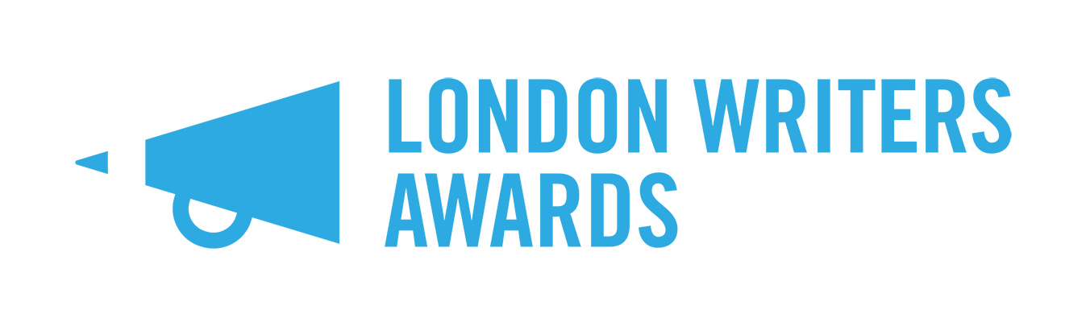
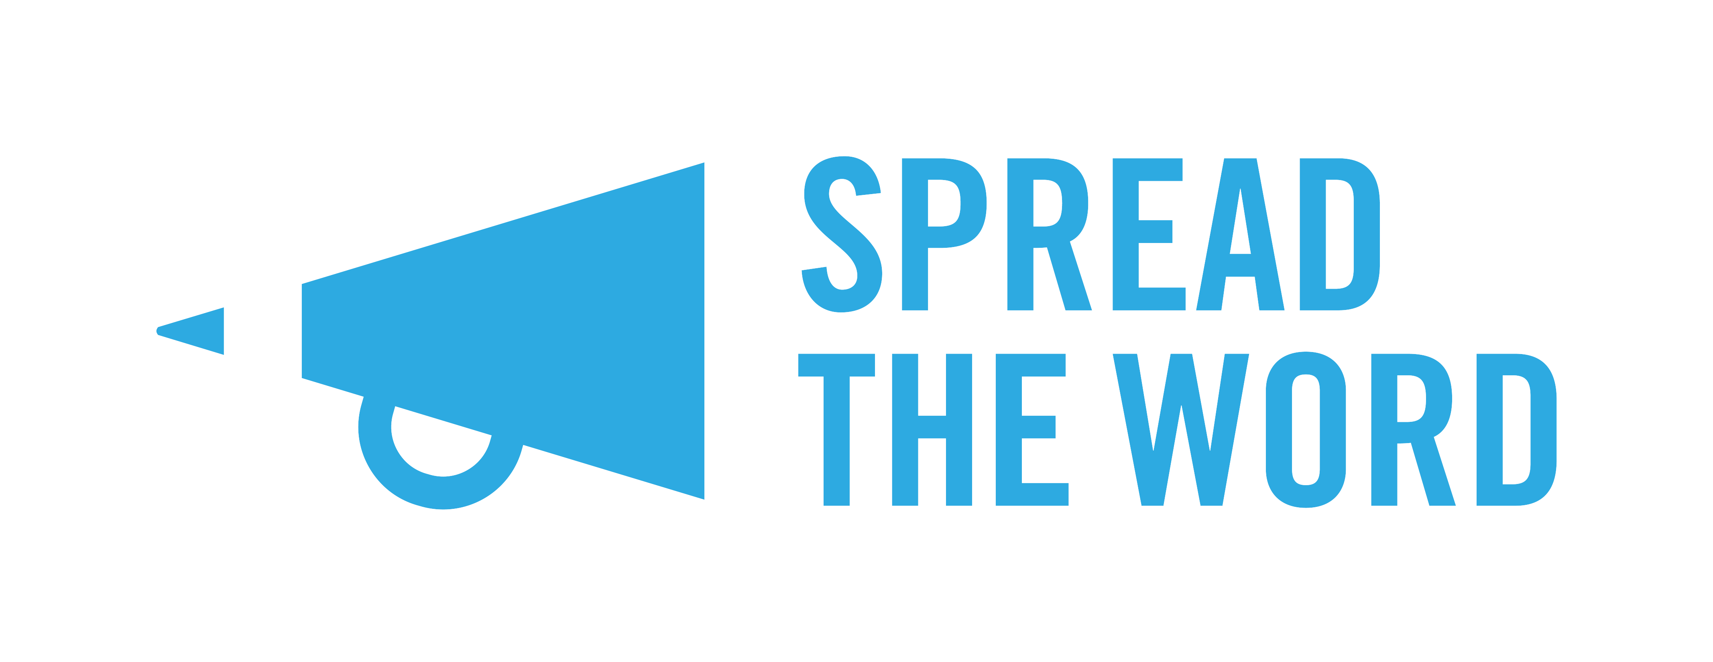

Everything you need to know about the London Writers Awards

Who we are and what we do

We are Spread the Word. We give support and advice to writers in London to get their work published. The London Writers Awards is our writer development programme.

We work with 30 writers from different backgrounds, cultures and life experiences who might find it harder to get published. We help them to learn new skills and have access to new and exciting opportunities.

We want to remove the barriers some people might face when they try to get published. By doing this we get to read and hear the work and stories of writers across the whole of society.

This guide tells you everything you need to know about The London Writers Awards including:

- Why we set up the Awards
- Who can enter
- How to enter
- What the Awards offer
- Entry fee and costs
- How the Awards will run this year
- How to apply for the Awards
- How we choose the writers
- Who is judging the Awards
- Funding and bursary money
- Access fund for disabled writers
- When to send in your application
- Anything else you need to know.

Why we set up the Awards

We set up the London Writers Awards to give more opportunities to writers who may not get the same chances as other people, including disabled people. We developed our writing programme to help new and emerging writers to

- Find an agent
- Get professional input and quality feedback
- Produce work that will be published
- Find a supportive community

Who can enter

Our Awards are aimed at adults who are 18 or over and live in London. We are looking for writers who are

- People of colour

- Working class or from a working-class background

- Lesbian, Gay, Bisexual, Transgender, Queer (LGBTQIA+)

- Disabled people – this might be a physical or a learning disability/difficulty.

You don’t need to enter a finished piece of work, but it is a good idea to send us something that you want to work on during the programme, if we choose you. Remember the programme runs for 10 months so you need to choose something that will work well during this time period.

How to enter

You can enter your work in 4 different categories of writing. You must not have an agent or have been published before. We want to see work that is

- Literary fiction – this includes short stories

- Commercial fiction – this means crime, romance, thriller or science fiction

- Narrative non-fiction – this is writing that tells a true story. For example, an autobiography, life writing or a memoir

- Children and Young Adult Fiction – this is writing aimed at young people but not picture books.

If you’ve been self-published before, then you can still apply but you need to send a piece of writing or book that hasn’t been published anywhere before.

What the Awards offer

If we choose you to join our writer development programme, you will get training, support and the chance to network with other writers, publishers and agents.

You will get:

- 2 critical feedback groups a month – these should provide valuable feedback on your project and give you a chance to feedback to each other
- 9 writing craft and career masterclasses with leading writers and professionals who work in publishing
- 2 Writers Labs with talks and workshops by writers, agents and publishers plus a networking event to meet editors and agents
- 1-2-1 professional development support sessions with Spread the Word staff
- Bursaries for writers most in need
- An access fund for disabled writers.

Entry fee and costs

You don’t have to pay anything to enter the Awards. But if you are chosen and have any travel or other costs, you will need to pay for this yourself. You can apply for money called a bursary to help you with your costs. Bursary money is for writers who are most in need of help. We also have an access fund for disabled writers. You can find out more bursaries and other financial support here: https://www.spreadtheword.org.uk/projects/london-writers-awards/

How the Awards will run this year

We are keeping a close eye on advice from the government about COVID-19. We think we will run the Awards and writer development programme online, and some of it in-person if it is safe and possible to do so. We will keep everyone who applies up to date with any developments.

The development programme will run from February 2022 until November 2022.

Key dates for the Awards and Writers Development Programme

Friday 1st October 2021 – Applications open
Wednesday 31st October 2021, 11pm – Applications close
18th / 19th / 29th January 2022 – Interview days (you will only need to attend on one day)
Saturday 26th February 2022 – Programme activity starts
Thursday 24th November 2022 – Programme ends

We will choose all the writers we select for the programme by the end of January 2022.

The programme will start on Saturday 26th February 2022 with Writers Lab 1. We will take a summer break in July and August, but you will still keep writing so you can keep focused on your project. The programme will end on Thursday 28th October 2022 with Writers Lab 2.

These are the dates we have at the moment, but some dates may change. We will confirm all dates for the programme in January 2022.

You will need to be available to take part over the ten months the programme which runs from February – November 2022.

The critical feedback groups will take place in the evening, twice a month and last 2 hours each time. There will be 13 sessions in total. You will also be expected to spend 1-2 hours reading other group members’ writing in preparation for each session.

There will be 5 creative writing masterclasses, and 4 career masterclasses. These will take place on Saturdays from February 2022 to November 2022. There will also be two Writers Labs – one to open the programme on Saturday 26th February 2022, and one to close the programme on Thursday 24th November 2022.

You must attend the Writers Labs as part of the terms and conditions of the programme. You will also need to find time to work on your writing project, so you can make progress on it during the development programme.

We estimate the development programme will take up approximately 30 hours per month. Please think about whether you can give this time before you apply.

How to apply for the Awards

There are four ways you can apply for the Awards/Development Programme

- Fill out the form on our on online submissions page (https://spreadtheword.submittable.com/submit);
- Download and print off our paper form which you can download from our website and post to us
- As an audio file. Please contact us if you wish to use this option
- As a video file if you use a BSL interpreter. Please contact us if you wish to use this option.

Please send or record a sample of your writing. This should be a short extract of no more than 3000 words from the project you’d like to develop. We don’t accept individual short stories or poems. If you would like to submit your application in another format, please get in touch with us so we can discuss in more detail.

How we choose the writers

Spread the Word has a team of readers who will read through your entries first. We will then choose the people we think should go through to the next round. A writer and industry professional will then judge these entries and some up with a shortlist of people to interview.

The people on the shortlist will either have an online Zoom interview or come and see us in person. The interviews will be on either the 18th / 19th / 20th January 2022. We will make offers to join our programme to 6 writers in Young Adult/children’s fiction, 6 writers in commercial fiction and 6 writers narrative non-fiction and 12 applicants in literary fiction. This makes a total of 30 writers winning an Award and getting the chance to take part in our writers’ development programme.

The judges

Our judges this year are:

- Literary fiction – Louise Hare, Ashley Hickson-Lovence, Matt Turner, Milly Reilly
- Commercial fiction – Sara Jafari and Emma Grundy-Haigh
- Narrative non-fiction – Sara Gibbs and Emma Bal
- Young Adult and Children fiction – Benjamin Dean and Davinia Andrew-Lynch

We can’t accept applications from writers who are:

- Currently or are about to be enrolled in a graduate or postgraduate creative writing programme (BA, MA or PhD)

- Part of a longer-term development programme for writers (such as the Faber Academy, Curtis Brown Creative, Jerwood Arvon Mentoring scheme, Penguin Random House Write Now, London Libraries Emerging Writers scheme)

- Have previously completed a creative writing course in the last two years, you are also not eligible to apply.

We have to have these rules so we can reach writers who haven’t had the chance to be published before.

Funding and bursary money

The London Writers Awards bursaries are aimed at writers who are:

- Carers or single parents
- Care leavers (i.e. an adult who spent time in care as a child)
- Have experience of being homeless
- Ex-offenders
- Unemployed
- On a low income - either benefits or a minimum wage zero hours
contract.

If you think you are the right person to apply for bursary money, please fill out the relevant section in your application form.

Access fund for disabled writers

If you are a disabled writer who gets disability allowance or a Personal Independence Payment (PIP), you can apply for our access fund. Please fill out the relevant section in your application form. The access fund is there to help you pay for any extra costs that help you take part in the Awards. For example, you may need to pay for a British Sign Language interpreter, extra personal assistant support, or something else related to supporting your writing work.

When to send in your application

Applications open on Friday 1 October 2021 and close at 11pm on Sunday 31 October 2021. We cannot accept any entries after this closing date.

We will get back to everyone who applies in January 2022. Because we get a lot of applications, we won’t be able to give individual feedback about your work.

Anything else you need to know

To find out more, please read our Terms and Conditions and Eligibility Criteria for the London Writers Awards. If you still have any questions, please email Bobby at bobby@spreadtheword.org.uk.

Good luck with your application!

