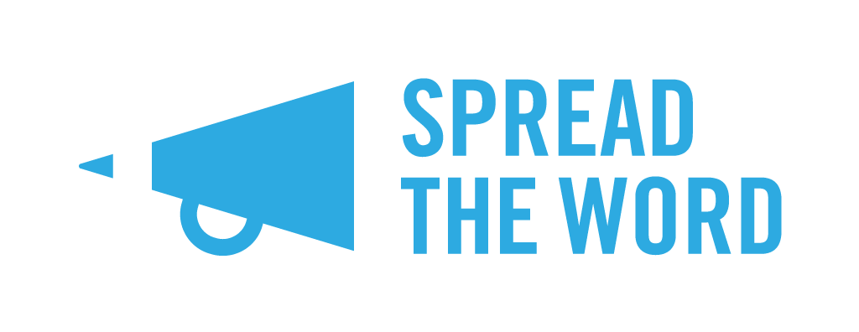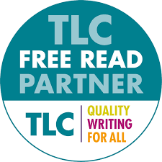
FREE READS 2022-2023: Spread the Word FAQs

What is The Free Reads Scheme?
The Literary Consultancy (TLC) Free Reads Scheme offers low-income writers the opportunity to get free professional feedback on their writing via TLC, the UK's leading editorial consultancy. It is funded by Arts Council England and managed by TLC.
This scheme is open to writers of fiction, non-fiction, children’s fiction including picture books, short stories, poetry, scripts and screenplays. Writers are hand-matched to a suitable reader from its list of 90+ professional editors and will receive either a partial or full read on their submission, with the feedback distributed in the form of a written critique by TLC. The Free Read Scheme particularly welcomes applications from writers belonging to groups currently under-represented in publishing including disabled writers, writers of colour*, and members of the LGBQTIA+ community.
How do I know if I’m eligible to enter the scheme?
You’re eligible for the scheme via Spread the Word if you’re on a low income and are based in London.
The following may apply:
- You are in receipt of Job seeker’s allowance, Disability Benefit, Income Support, Working Tax Credit, Universal Credit or Child Benefits
- You earn less than or up to the London Living Wage of £11.05 per hour or a £23,000k annual salary
- You are a full-time student
- You are aged 60 or over**
You must be over 16 years of age to apply and your submission must be in English. You can read the full Rules and Guidance on entering the scheme via TLC’s website.
If I am on a low income but don’t fit the eligibility criteria, can I still apply?
Certainly. If you are on a low income but do not meet one of the criteria listed above then please get in touch by emailing Eva at Eva@spreadtheword.org.uk, as we are able to evaluate applicants’ eligibility on a case-by-case basis.
Hang on - you’ve said you only accept applications from London writers. I’m not based in London – can I still apply?
As TLC’s regional partner for London, Spread the Word is only processing entries from London-based writers. However, Free Reads is open to all writers residing in England through a range of partners. You can find a map of the partners operating in each region, as well as more information about the scheme on TLC’s website. Please be aware that each regional partner will have their own deadline dates so be sure to check these out asap, so you can apply in good time.

Ok, I’m going to apply - what do I need to send in?
Fab news! You’ll need to send in the following:
- A completed application form (see Note below)
- A complete synopsis of the written work submitted. The synopsis must clearly show your story’s outline and should not exceed 1,000 words. We highly recommend that you check out our Pocket Guide to Writing a Synopsis before sending yours in
- Evidence of how you meet the scheme’s criteria
- An extract of your writing (up to 1000 words if your writing is prose or up to 20 pages if it is poetry or script writing)

Note: on the application form, the question Length of Submission refers to the length of the whole work you want to have read, not to the length of the extract you are attaching in support of your application.

What do you mean by ‘evidence’?
You’ll need to provide some documentation to confirm that you meet the criteria. This could be: benefits letter, payslips, HMRC self-assessment paperwork or tax statement, confirmation of full-time student status, pensions slips, or anything else that confirms your eligibility. These documents will be removed from our system once the application process is complete.

I’m not a fiction writer, can I still apply for a Free Read?
Yes - the scheme is open to writing across fiction, creative non-fiction, children’s fiction including picture books, short stories, poetry, stage, tv and radio scripts and screenplays. If you are not sure if your work is eligible, please email Emily@spreadtheword.org.uk

I have a disability and would like to enter my submission through a different format, i.e. audio, signed, other formats. Can I do this?
Absolutely. We have the option open for participants to send in audio and visual submissions, and please get in touch with us if you would like to submit through a channel that is not available on the Submittable application form by emailing Emily at Emily@spreadtheword.org.uk

My work isn’t complete – can I still enter?
Yes - the Free Reads Scheme offers either a partial or full manuscript assessment so there is an option to have part of your work assessed. However, you must be able to produce a clear synopsis of how your story develops. If you do not yet know the ending, that is absolutely fine.

How do I submit?
You must submit via Submittable. You’ll find the link to this on our website.

Note: on the application form, the question Length of Submission refers to the length of the whole work you want to have read, not to the length of the extract you are attaching in support of your application.

I’m a co-author for a piece, can I apply?
No, only single authored works are accepted for a Free Read.

I applied last year for a Free Read, can I apply again?
No. As per TLC’s rules applicants cannot apply two years in a row for a Free Read. You’re welcome to apply to our other opportunities on our website and to the Free Reads Scheme next year.

When’s the deadline to enter?
The submission window is from: Monday 1 August to Friday 30 September (11.59pm BST).

I’ve sent it off – now what?
Great news. We’ll notify you in mid-November if you have been selected for a Free Read.

I’ve been offered a Free Read, what do I do next?
Congratulations! You either will have been selected for a full manuscript assessment or a partial manuscript assessment – please check this in your email.

In the same email you will also be given guidelines on what to do next and how to submit your work to us. You’ll have four weeks to put your work together and send it to us via email. We will then pass it onto TLC, who will match your manuscript to a suitable reader from its list of 80+ professional editors. They will provide a written critique of your work within 4-6 weeks of the application being processed. You should receive your feedback by mid-February 2022.

I didn’t get offered a Free Read. Can I ask for feedback?
Unfortunately not. We receive a high number of entries for this scheme which means it isn’t possible to provide feedback on each entry.

My question isn’t listed here – what do I do?
Drop Eva an email at Eva@spreadtheword.org.uk and we’ll get back to you as soon as we can.

*Writers of colour: Black, Asian, and Global Majority ethnicities
**You must have an annual income of £23,000k or less, including pensions and other forms of income

