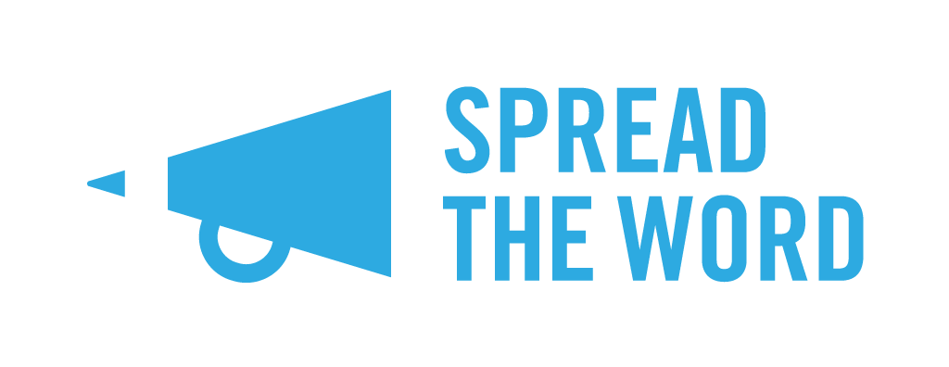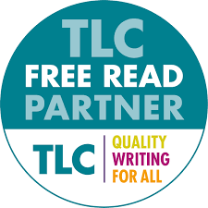
FREE READS 2023-34: Spread the Word FAQs

What is Free Reads?
The Literary Consultancy (TLC) Free Reads scheme offers low-income writers the opportunity to get free professional feedback on their writing. It is funded by Arts Council England and managed by TLC. This scheme is open to writers of fiction, non-fiction, children’s fiction including picture books, short stories, poetry, scripts and screenplays.
This year’s Free Reads offers the traditional Manuscript Assessment, plus two new offers: a Submissions Package Report and Editor One-to-One.
Free Read particularly welcomes applications from writers belonging to groups currently under-represented in publishing including disabled writers, writers of colour*, and members of the LGBQTIA+ community.
Wow! Now there are three options to apply for. What’s right for me?
This depends on where you are with your writing project, and what you need. To make sure you’re applying for the right offer, we’d recommend carefully reading through the questions below.
What’s a manuscript assessment and who’s it for?
Writers are hand-matched to a suitable reader from a list of 90+ professional editors and will receive either a partial or full read on their submission, with honest, detailed and professional market-aware feedback distributed in the form of a written critique by TLC. This offer is for writers who are looking for editorial feedback on their manuscripts at whatever stage of development. This is the original offer for Free Reads.
Great! This is for me – but my work isn’t complete. Can I still enter for a manuscript assessment?
Yes - Free Reads offers either a partial or full manuscript assessment so there is an option to have part of your work assessed. However, you must be able to produce a clear synopsis of how your story develops. If you do not yet know the ending, that is absolutely fine.
Ok! What about the new submissions package report – what is this?
This offer is for writers with a completed manuscript who have already had a manuscript assessment or editorial feedback (this can be from TLC or any other source of editorial support), who want to refine and polish their submissions package to send out to agents. Writers are matched with a TLC Industry Editor who will read their first 8,000 words, synopsis, and ‘Dear Agent’ letter, providing them a written report and mark-up or commentary on the submission material.
And the new editor one-to-ones – what is this and who should apply?
Writers will meet with a TLC Editor for a one-hour session to trouble-shoot or generate ideas or offer advice and motivation through writer’s block. One-to-ones are popular with writers who have had an editorial service and need post-feedback support. The TLC Editor will provide you with goal-setting worksheets and a recording of your session, so you can watch back anytime. The writer has one hour with their editor plus one hour of prep time where your editor reads up to 2,500 words (or the equivalent in poetry/script/treatment).
Can I apply for all three offers – a manuscript assessment, submissions package report, and an editor one-to-one?

You can apply for all three – but realistically we will only award you one of the offers you apply for so we can offer the opportunity to as many people as we can.

How do I know if I’m eligible to enter the scheme?
You’re eligible for the scheme via Spread the Word if you’re on a low income and are based in London.
The following may apply:
- You are in receipt of Job seeker’s allowance, Disability Benefit, Income Support, Working Tax Credit, Universal Credit or Child benefits
- You earn less than or up to the London Living Wage of £11.95 per hour or a £23,000k annual salary
- You are a full-time student
- You are aged 60 or over**
You must be over 16 years of age to apply and your submission must be in English. You can read the full Rules and Guidance on entering the scheme via TLC’s website.

If I am on a low income but don’t fit the eligibility criteria, can I still apply?
Certainly. If you are on a low income but do not meet one of the criteria listed above then please get in touch by emailing Emily at emily@spreadtheword.org.uk as we are able to evaluate applicants’ eligibility on a case-by-case basis.
Hang on - you’ve said you only accept applications from London writers. I’m not based in London – can I still apply?
As TLC’s regional partner for London, Spread the Word is only processing entries from London-based writers. However, Free Reads is open to all writers residing in England through a range of partners. You can find a map of the partners operating in each region, as well as more information about the scheme on TLC’s website. Please be aware that each regional partner will have their own deadline dates so be sure to check these out asap, so you can apply in good time.

Ok, I’m going to apply - what do I need to send in?
Fab news! You’ll need to send in the following:
- A completed TLC application form (see Note* below)
- Evidence of how you meet the scheme’s criteria
- A complete synopsis of the written work submitted. The synopsis must clearly show your story’s outline and should not exceed 1,000 words. We highly recommend that you check out our Pocket Guide to Writing a Synopsis before sending yours in
- An extract of your writing (up to 1000 words if your writing is prose or up to 20 pages if it is poetry or script writing)

Note*: on the application form, the question Length of Submission refers to the length of the whole work you want to have read, not to the length of the extract you are attaching in support of your application.

I want to apply for a submissions package report or an editor one-to-one. Which application form should I fill out?
A new TLC form will be made available on our website page in the week commencing 29 August to apply for a submissions package report or an editor one-to-one. If you want to apply for a manuscript assessment, you can complete the standard TLC form provided on our website page in PDF and Word formats.

What do you mean by ‘evidence’?
You’ll need to provide some documentation to confirm that you meet the criteria. This could be: benefits letter, payslips, HMRC self-assessment paperwork or tax statement, confirmation of full-time student status, pensions slips, or anything else that confirms your eligibility. These documents will be removed from our system once the application process is complete.

I’m not a fiction writer, can I still apply for a Free Read?
Yes - the scheme is open to writing across fiction, creative non-fiction, children’s fiction including picture books, short stories, poetry, stage, tv and radio scripts and screenplays. If you are not sure if your work is eligible, please email Emily@spreadtheword.org.uk

I have a disability and would like to enter my submission through a different format, i.e. audio, signed, other formats. Can I do this?
Absolutely. We have the option open for participants to send in audio and visual submissions, and please get in touch with us if you would like to submit through a channel that is not available on the Submittable application form by emailing Emily at Emily@spreadtheword.org.uk

How do I submit?
You must submit via Submittable. The link to apply is here. You’ll find the link to this on our website.

Note: as mentioned earlier, on the application form, the question Length of Submission refers to the length of the whole work you want to have read, not to the length of the extract you are attaching in support of your application.

I’m a co-author for a piece, can I apply?
No, only single authored works are accepted for a Free Read.

I applied last year for a Free Read, can I apply again?
Yes – if you applied last year and were not selected for a Free Read, you are eligible to apply again this year. You cannot apply if you’ve been previously awarded a Free Read.

When’s the deadline to enter?
The submission window is from: Monday 24 July – Monday 2 October 2023.

I’ve sent it off – now what?
Great news. We’ll notify you in mid-December if you have been selected for a Free Read.

I’ve been offered a Free Read, what do I do next?
Congratulations! We will get in touch with you about the next steps – please check this in your email. In the same email you will also be given guidelines on what to do next and how to submit your work to us. You’ll have seven weeks to put your work together which reflects the size of the Free Read you have been given (for example, full manuscript or 5000 words) and/or the additional documents you would like to be assessed (for example, ‘Dear Agent’ letter) and send it to us via email. We will then pass it onto TLC, who will match you with one of their industry experts.

If you applied for a manuscript assessment, you’ll be matched with a suitable reader from the TLC’s list of 90+ professional editors. They will provide a written critique of your work within 4-6 weeks of the application being processed. You should receive your feedback by end of March 2024.

If you applied for a submissions package report or editor one-to-one, you will receive your written feedback or have your editor meeting set up within 4 weeks.

I didn’t get offered a Free Read. Can I ask for feedback?
Unfortunately not. We receive a high number of entries for this scheme which means it isn’t possible to provide feedback on each entry.

My question isn’t listed here – what do I do?
Drop Emily an email at emily@spreadtheword.org.uk and we’ll get back to you as soon as we can.
*Writers of colour: Black, Asian, and Global Majority ethnicities
**You must have an annual income of £23,000 or less, including pensions and other forms of income

